Organisational Resilience Programme 2024
Funded by Lloyds Bank Foundation
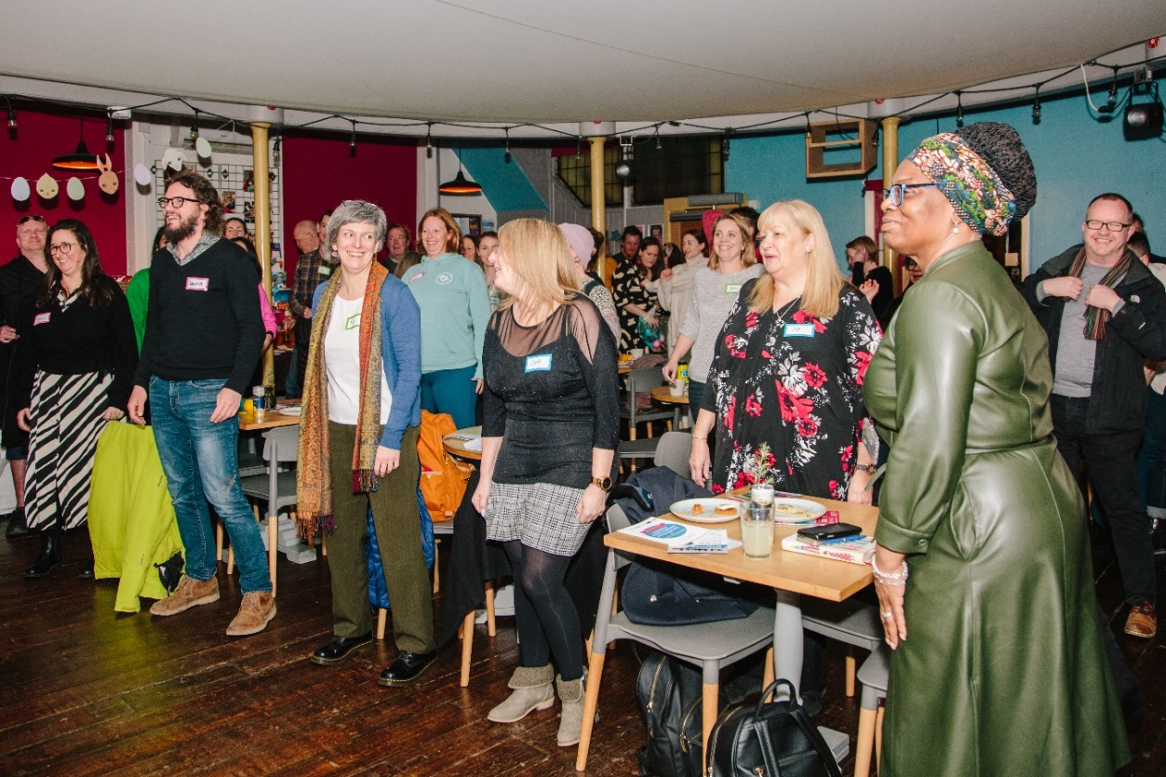
Guidance notes
Telford & Wrekin, and Great Yarmouth

Table of contents

Introduction | Pg 3
Who is the Organisational Resilience Programme for? | Pg 3
What is the Organisational Resilience Programme? | Pg 3
What are the aims of the Organisational Resilience Programme? | Pg 4
How will the programme work? | Pg 4
The Programme details | Pg 6
Is the programme right for you? | Pg 9
Eligibility Criteria | Pg 9
How to apply | Pg 9
Inclusion at SSE. | Pg 10

Introduction
We recognise that there are many organisations from different sectors creating positive change for our communities. But, to create true systemic change, organisations from all different sectors need to come together, to understand and appreciate different perspectives, to look at the same challenge through other lenses to work together and find a collective way forward.

Who is the Organisational Resilience programme for?
We want to work with voluntary, community and social enterprise leaders who are passionate about actively engaging with other regional connections to make a real change to how we work on social problems.
For the first year of the programme, we are going to run this with participants from the Telford and Wrekin, and Great Yarmouth areas.
For this programme charity and social enterprise leaders from these areas will come under Stream A.
Other regional stakeholders such as local businesses, funders, local authorities, and commissioners from these areas will come under Stream B.

What is the Organisational Resilience programme?
Building upon the work that communities and the Lloyds Bank Foundation are doing in Great Yarmouth, and Telford and Wrekin, the Organisational Resilience programme aims to add value, bolster, and strengthen organisations so that they are best placed to do the amazing work that they do.
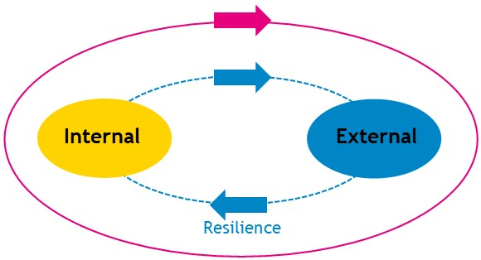
To build resilience, charities and social enterprises need to develop an internal resilience – that will develop the conditions so that their people, their money, and their purpose are resilient.
However, charities and social enterprises are one piece in a wider and complex system, working with an eco-system of other businesses, funders, commissioners, and local authorities. This eco-system also needs support to ensure the external resilience of communities.
The Organisational Resilience is a free, fully funded programme run in partnership with the Lloyds Bank Foundation in which we will provide internal resilience support for charity and social purpose leaders, provide clarity, and focus for regional businesses, funders and commissioner and then provide the collective with the facilitated focused space to focus and deep dive on an aspect of the community challenge. We will work with you and the Lloyds Bank Foundation team to help discuss the area of the community challenge to focus on and help accelerate the work into action.
“Organisational Resilience is the ability of an organisation to anticipate, prepare for, respond and adapt to incremental change and sudden disruptions in order to survive and prosper.”

Organisation Resilience: A summary of academic evidence, business insights and new thinking from British Standards Institution and Cranfield School of Management.

What are the aims of the Organisational Resilience programme?
There are four main aims for the programme.
- To provide the opportunity for charity and social purpose organisations to strengthen their business and improve their internal resilience.
- To help the wider eco-system develop their practice and understand each other.
- To bring this ‘community of interest’ together to establish goals, and process and hold the actions to account.
- To develop a new way of working and a legacy that will continue beyond the life cycle of the support programme.

How will the programme work?
The Organisational Resilience programme has two elements that will start independently before then coming together.
Stream A – Working with charity and social purpose business leaders, we will provide time and space to work ‘on’ rather than ‘in’ your organisation. Using the Lloyds Bank Foundation Organisation Resilience programme, you will work with a peer group of like-minded leaders to deep dive and evaluate your organisation’s purpose, financial agility, and people. We will share success and best practice, whilst also identifying individual development areas and then help you to consider the best strategy to put in place.
Aims of stream A – To strengthen social businesses in order that they can strengthen their market position, hone their products and services on offer to best serve the communities, and boost confidence in their organisations ability to anticipate, prepare, respond, and adapt.
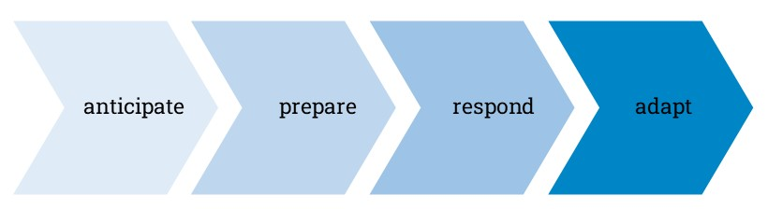

Stream B – Here, we will bring together regional businesses, funders, commissioners, and local authorities to discuss the ecosystem, and the community challenge. What are the commonalities? What are the challenges? What do you need to do the best work? What are the boundaries? How do you feel about risk?
Aims of stream B – To help each participant be clear on their intentions, to strengthen their offer, to consider their boundaries and business considerations and to help identify the common challenges.
Following some time working in these two groups, we will bring the groups together from a stronger and more confident foundation to then deep dive into an aspect of the identified community challenge to push this along and ensure progress.
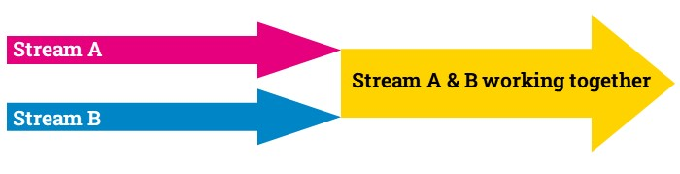

The Programme details
The School for Social Entrepreneurs’ learning programmes are very different to traditional teaching. We’re not about essays and lectures. You will hear from expert practitioners and seasoned charity leaders; social entrepreneurs and business leaders who help you develop the skills you’ll need to build your organisational resilience to increase your impact and sustainability.

Recruitment dates
Enrolments close | 12th February 2024
Enrolments confirmed in place | 19th February 2024
Introduction welcome session (online) | 7th March 2024
Programme begins | March 2024

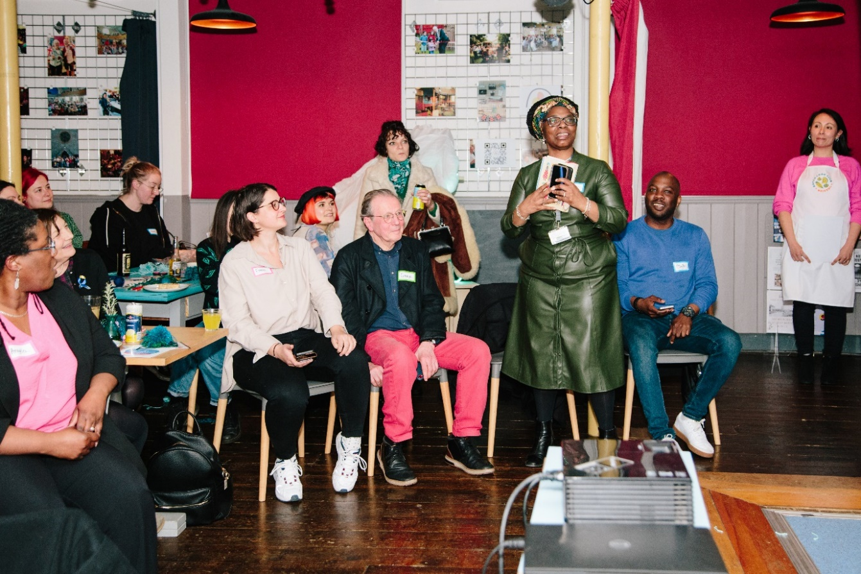

Programme Dates
Welcome session | 2 hours | Online | 7th March
Residential One | 2 days | In person | 20th & 21st March | Stream A only
Online session one | 2 hours | Online | 18th April
One to One | 1 hour | Online | 16th May
Online session two | 2 hours | Online | 13th June
Residential Two | 2 days | In person | 3rd & 4th July | Stream A for day 1. Stream A & B for day 2
Action learning set 1 | 3 hours | Online | 18th July
One to One | 1 hour | Online | 5th Sept
Action learning set 2 | 3 hours | Online | 26th Sept
Online session three | 2 hours | Online | 10th Oct
Residential Three | 2 days | In person | 23rd & 24th Oct | Stream A for day 1. Stream A & B for day 2
Action learning set 3 | 3 hours | Online | 20th Nov
Action learning set 4 | 3 hours | Online | 12th Dec
Catch up session | 2 hours | Online | 8th May 2025
Total = | 10 days maximum

The 10-day programme will be delivered over 10 months using a combination of in-person and online zoom sessions as shown above and will include:
Residentials
There are three residential sessions in total. The first one in March is purely for Stream A – the charity and social purpose leaders to come together to work on strengthening your internal organisational resilience.
Residential 2 and 3 are also both two days long. The first day will just be for stream A, the charity and social purpose leaders to continue the internal resilience work and discussions. We will then be joined by stream B for day 2 where we can then work together on the shared challenge and the external ecosystem resilience.
The residentials will involve group work, discussions, workshops, contributions from experts and other charity and social enterprise leaders.
Online Sessions
The online sessions provide valuable touchpoints in between the in-person residentials. To ensure momentum, we will identify themes and discussion points that add value to the work you are doing and bring in expertise to help with progression.
Action learning sets
In small groups, you will work with trained facilitators to help find ways of overcoming challenges in a peer-coaching setting. Our aim will be to help build the foundation with this process with the intention that the action learning sets can continue way beyond the life cycle of the programme. Many do!

One to Ones
We have the option of having individual support by meeting your learning facilitator for business coaching sessions that will help to identify individual challenges, focus on priority setting and provide a sounding board.

Time commitment. Giving 10 days over 10 months but getting so much more back!
We fully recognise that everyone is hugely busy. Our 25 years of experience and feedback from social leaders have informed us how we continue to learn and design programmes. We recognise the value of bringing people together in person, to maximise connection, communication, network development and action.
There are also huge gains to be made by stepping away from your organisation, for just a day or so to help gain a reflective perspective.

“The SSE programme has taught me the importance of a strong network of support, both to challenge and to advise. But most importantly it gave me the time and space to stop and think about my organisation in order to take the best path forward.”

Kate – SSE Fellow

Is the programme right for you?
This is the right programme for you if:
- You are leaders of a charity or social enterprise that wants to ensure that your organisation is in the best possible position to anticipate, prepare, adapt, and respond.
- You want to meet a cohort of peers to celebrate success, share challenges, contribute to, and learn from each other.
- You are passionate about actively engaging with other regional & local stakeholders to make a real change to how we work on societal problems.

Eligibility Criteria

The programme is exclusively for Lloyds Bank Foundation engaged organisations and will not be marketed or available publicly.

To be eligible, you need to:

- Be located and based in Telford and Wrekin, or Great Yarmouth
- Working with and for people living in Telford and Wrekin, or Great Yarmouth.
- Have connections with Lloyds Bank Foundation and the Local Implementation Leads (LIL’s) to work towards tackling homelessness (Great Yarmouth) or unlocking potential (Telford and Wrekin).
- Be a voluntary organisation, community organisation, social enterprise, or charity (Stream A) OR
- Be a public sector organisation, including health, Local Authority, housing providers, further or higher education provider or a regional funder, commissioner, or local business, that has engaged with the Lloyds Bank Foundation. (Stream B)

How to apply
Please enroll for this programme is 12.00pm on Monday 12th February.

To enroll for this programme please go to the website and complete the enrolment form link.

Apply Here

All applications will be assessed against the above criteria.

Accessibility and our commitment to inclusion

We recognise that discrimination of all sorts infiltrates every part of our society, and we are working hard to counter that wherever we find it. To that end, we actively encourage applications from people of all faiths, races, gender identities, sexual orientations, economic circumstances, and backgrounds, as well as those from disabled communities. No educational qualifications are needed to join our programmes.

We want our programmes to be as accessible as possible.

If you require reasonable adjustments to participate in the programme due to a disability, caring responsibilities, or any other reason, you will be able to provide details in the application form or contact us by phone or email to discuss further.

If this document is formatted in a way that is not accessible to you, please email Felicity Day on felicity.day@sse.org.uk or call us on 020 089 9120 so we can share an accessible version.
Inclusion at SSE: questions at the end of the application form
At the end of the application form, you will be redirected to complete an additional form. This asks you for information that helps us better understand who we attract to our programmes. You don’t have to answer this section, but it will help us become a more inclusive organisation if you do.

We care about diversity and inclusion in every aspect of our work and beyond. We care about the students we recruit, the content of our programmes, the way they are delivered, and the people delivering them. We are also committed to learning and assessing our progress. We cannot assess our progress unless we collect this data.

Please be assured that your completion of this additional form is not tied to your application in any way and is separated from each application we receive. We want a fairer society, we want to be inclusive, and we want to fight bias at every step. We’d be really grateful if you could spare the time.

Thank you.

