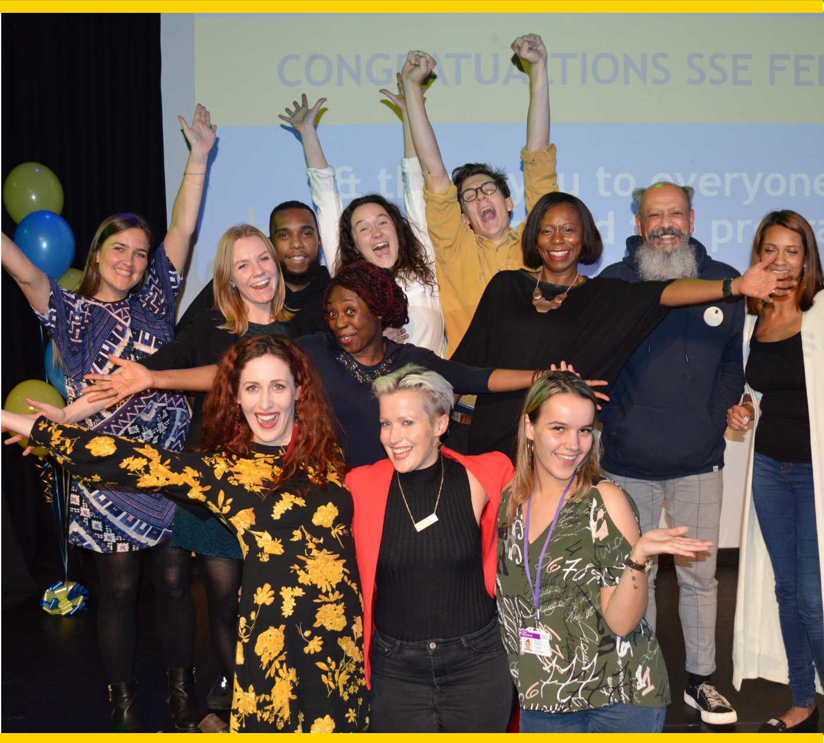
Trade Up 2020-21 Application guidance notes – large print plain text

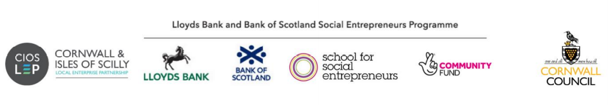
Important information for applicants

We have adapted this programme in response to the impact of the Covid-19 crisis.

Our recruitment process is fully online, including applications, interviews, and assessments.

The learning programme will integrate both online and in-person learning. However, our learning programmes will be fully online until government guidance on social distancing changes.

Our inclusion commitment: We encourage and welcome applications from social entrepreneurs from all backgrounds and are looking to make a real difference to the lives of their local communities. We want to make sure this programme supports communities that face systemic barriers.

We welcome applications from everyone with priority given to:

- those working in deprived areas
- people of colour and from minoritised ethnic backgrounds
- disabled people
- LGBTQ+ people
- and/or organisations supporting these groups.

Table of content
s
Introduction 3
What are these guidance notes for? 4
Accessibility and our commitment to inclusion 4
About the School for Social Entrepreneurs 6
The Trade Up Programme 7
Eligibility 9
Please do not apply if… 11
What is the time commitment and schedule? 13
The Trade Back grant 13
What if my income from trading does not increase? 14
What do we mean by income from trading? 15
What can I spend the Trade Back grant on? 16
How do I apply? 18
Assessment timeline 21
What are we looking for? 22
Key contact details 23
Appendix: FAQs 24

Introduction
The Lloyds Bank and Bank of Scotland Social Entrepreneurs Programme: Trade Up

The Lloyds Bank and Bank of Scotland Social Entrepreneurs Programme is run in partnership with the School for Social Entrepreneurs and jointly funded by The National Lottery Community Fund.

The programme gives social entrepreneurs the best possible chance of success, particularly during these challenging times through access to support, learning and funding. The programme will equip you with the skills and networks to increase income from trading and financial resilience for a greater social and/or environmental impact.

The programme has supported over 2,000 social entrepreneurs in the UK since 2012 with over a third of the social enterprises operating in the most economically disadvantaged communities.

What are these guidance notes for?
This document explains more about the programme and grant, and how to apply. Please also feel free to LBSEP2021@sse.org.uk if you have read the application guidance but are unsure about suitability for the programme.

Accessibility and our commitment to inclusion
If this document is formatted in a way that is not accessible to you, please email LBSEP2021@sse.org.uk or call us on 0207 089 9120.

We want our programmes to be as accessible as possible. If you require reasonable adjustments for the application and assessment process or to participate in the programme due to a disability, caring responsibilities or any other reason, you can provide details in the application form or contact us by phone or email to discuss further.

If you identify as neurodiverse please refer to the FAQ on page 25.

No educational qualifications are needed to join our programmes.

Do I need to answer the Equal Opportunities questions?
The first part of the application asks you for information that helps us better understand who we attract to our programmes. You don’t have to answer this section, but it will help us become a more inclusive organisation if you do.

We care about diversity and inclusion in every aspect of our work and beyond. We care about the students we recruit, the content of our programmes, the way they are delivered, and the people delivering them. We are also committed to learning and assessing our progress. We cannot assess our progress unless we collect this data.

Please be assured that your monitoring completion is not tied to your application in any way and is separated from each application we receive. We want a fairer society, we want to be inclusive and we want to fight bias at every step. We’d be really grateful if you could spare the time – thank you.

Remember to apply in time!
The deadline for applications is 1pm, Friday 16th April 2021

Apply online here: https://salesforce.123formbuilder.com/form-5838099/

We recommend attending an online information session and starting your application as early as possible, so we can help you with any questions you have.

About the School for Social Entrepreneurs
We can’t fix issues like poverty, climate change and ill-health alone. That’s why the School for Social Entrepreneurs (SSE) exists. We help 1,000 people a year develop the skills, strengths and networks they need to tackle society’s biggest problems. Please click the following links to find out more:
- We are the School for Social Entrepreneurs
- The SSE effect!

We run courses that equip people to start, scale and strengthen organisations that make a positive difference. But we’re not a traditional school. Learning with SSE is inspiring, action-based and accessible – no textbooks. Lord Michael Young founded SSE in 1997. Today we work internationally, with teams across the UK, Canada and India.
Together, we’re changing lives and transforming communities.

The Trade Up Programme

In a nutshell:
- Free learning programme made up of 10 learning days, four Action Learning Sets, spread between October 2021 and October 2022 in full day and half-day sessions.
- Up to £4,000 Trade Back grant
- A community of like-minded people to meet regularly and work through challenges.
We value diversity and inclusivity and believe in the power of the group through peer-learning, collaboration, reflection and being yourself. This programme will be responsive to the needs of participants and encourage innovation to help you lead on social/environmental change and build a stronger and resilient business model.

There are three Trade Up cohorts with 60 places in total. The programme will be delivered by the following regional teams:
- SSE in London
- SSE in Cornwall
- SSE North West
We have a limited number of places for organisations based in Wales, Scotland, Northern Ireland and the Channel Islands.
What will I do on the programme?
The programme will push you, building your confidence and skills. Expect to try new approaches and learn through doing. The School for Social Entrepreneurs’ learning programmes are very different to traditional teaching. We’re not about essays and academia.
- Learn from experts, leaders and social entrepreneurs who will speak frankly about the good, the bad and the ugly of running an organisation so you can learn from their experiences. (This playlist of videos shares the types of stories you’ll hear.)
- Build a support network. You will be in a cohort of around 20 people to learn together as the programme emphasises peer-based learning.
- Join an Action Learning Set: a valuable space with a small group of people in your cohort to guide each other to developing your own solution to challenges.
What will I gain?
The programme is a transformational experience that will push, challenge and support you. It will give you the confidence and skills to achieve the impact you are aiming for, including:

- Improved entrepreneurial skills to increase income from trading and strengthen financial resilience.
- Skills to expand your reach, increase social or environmental impact and evidence the impact.
- Management and leadership skills to innovate, respond to challenges and create the change.
- Access to a mentor and a support network through peer learning with people in the same boat as you.

Our learning managers are expert facilitators, so they’ll flex learning to ensure everyone’s needs are met, as well as creating a great group dynamic.

Some of the topics we are likely to cover are:
- Social impact measurement
- Develop the link between your trading and your impact goals
- Develop your business plan and diverse income streams
- Test and refine your marketing skills and grow your customer base
- Financial resilience and sustainability
- Planning and management
- Improve your leadership skills
- Develop your networks
Not sure if the Trade Up programme is right for you? Consider Start Up or Scale Up on the web page here.

Eligibility
Who is this programme for?
We’re looking for people leading a project or organisation with social or environmental purpose and realistic plans to increase their income through trading.

If your income from trading has ceased, we recognise that your focus may be centred around rebuilding and recovery and restarting your trading. Find out what we mean by income from trading in FAQs.

Can I apply?
For Trade Up, you will need to show that you are an early stage and growing business, planning to increase your income from trading to achieve sustainability. Your plans may include for example:

- Developing new markets, products, services and increasing sales
- Providing/improving services in new areas or in different ways
- Developing new partnerships

To be eligible for this programme, your organisation must have:

- Been active for at least one year with a proven track record
- At least one regularly paid worker (this could be just you)
- An annual income of more than £15,000 * Go to FAQ for more information on income
- A formal governing document in place for your organisation. In exceptional circumstances we may consider sole traders if they are in the process of registering an organisation
- An ‘asset lock’, meaning that it must distribute any assets for social purposes, not private gain, if wound up?
- Most of your work and beneficiaries are based in England. We have limited places for Scotland, Wales, Northern Ireland and Channel Islands.
*We will consider the impact of Covid-19 when assessing the income criteria. So, if you were expecting to have £15,000 income this year, but you are not going to because of Covid-19, please tell us about this in your application form. We will take this into account.

About you:
- You are socially driven, action oriented, passionate about change, a reflective and active learner and collaborative.
- You are committed to attending the learning programme, (the grant is dependent on 80% attendance)
- You are aged 16 or over.
- You live in the UK and have the right to work in the UK.

Please do not apply if…
- You plan to develop a purely commercial business
- Your project is primarily to provide business development support and advice to other organisations
- Your project will be undertaking party political activities or will aim to induce people to convert to a religion (proselytising
- Your project will not have a formal constitution or legal structure by the start of the programme

Programme at a glance
Witness sessions
Entrepreneurs share their experiences and discuss the secrets of their success. You will be able to listen, learn and question them to help you examine and find meaning for your own project.

Expert sessions
Through questioning, observing and listening to experts, you will improve your abilities in financial management, income generation, business planning, sales and marketing, managing people, partnering and other essential skills.

Action learning sets
You will work in a small group with a trained facilitator, to help you find ways of overcoming the stumbling blocks, dilemmas and other problems that your project faces.

Mentoring
You will be matched with a mentor, who will help you build your confidence and understanding, and develop your project.

Trade Back grant
A Trade Back grant of £4,000 to help you develop your project.

Peer support
You will bring your skills and experience to the group and learn from the skills and experience of the other members. This network of like-minded people will provide vital support to enable you to develop your enterprise.

What is the time commitment and schedule?
The learning sessions will be typically spread over 12 months from October 2021 as either/or a combination of half day sessions and full day sessions.
Sessions will typically not take place during the school holidays and half terms.

- 10 x learning days
- 4 x Action Learning Sets
- A graduation in October 2022 to celebrate your achievements and completing the programme
The learning programme is only part of the picture though. You will need to be developing your project during the year and will need to have the time and commitment to do this.

The Trade Back grant
Our Trade Back grant helps organisations to get back on track following the Covid-19 crisis. We also want to support you to improve your financial sustainability by increasing your income from trading and sales. You will be matched with a grant manager throughout the year to support you with questions about your grant and how you can spend it.

We will set aside £4,000 of funding for your organisation as part of this programme.

You’ll get:
- An instant grant of £2,000 to kick-start recovery efforts and support you to put into practice new ideas and initiatives.
- Plus, up to a £2,000 grant that pound-for-pound matches an increase in income from trading. This is an incentivised* grant to accelerate recovery and growth.
- This element of the grant will be paid in instalments on a quarterly basis and will be matched against an increase in trading. The increase will be measured against a baseline that we will set with you. For some organisations, this baseline could be very low, i.e., close to zero.
Watch our 80-second video explaining Trade Back grants.

What if my income from trading does not increase?
We will work hard with you to support you to increase your trading, and we hope you will. We want to give you the money and believe you have the potential to achieve this growth.

If you don’t increase your income from trading at all, you will still receive the £2,000 instant grant, participate in the learning programme and graduate if you have attended 80% of the course.

What do we mean by income from trading?
Our definition of trading is the provision of goods or services in return for a “consideration”. Consideration usually means money, but could also be in-kind or bartering, as long as this is quantified and shown in your accounts.

Income from trading includes:
- Sales of goods or services to the public, for example - selling food, tickets, training sessions, workshops
- Sales of goods or services to other organisations, for example, training courses, commissions, contracting
- Sponsorship and membership fees, where there is a significant benefit for the sponsor or member
- Rental income
It does not include:
- Donations or voluntary contributions
- Income from investments
- Bank interest
- Loans
- Equity income (e.g. through sale of shares)
- Grants, for example from trusts
- Transfers of funds from other organisations, e.g., in the case of a merger
- Sponsorship or membership fees, where there is no significant benefit to member or sponsor
We can advise you about this if you are not sure. And just to be clear, by income from trading we don’t mean surplus or profit – just income.

What can I spend the Trade Back grant on?
We will be as flexible as possible about how you spend the grant. But your grant must be used to support your learning and to put that learning into practice through developing trading within your organisation.

You can use your grant towards items such as:
- Your salary or staff salaries to support you to attend the programme or to support the development of trading in your organisation
- Developing new products or services
- Marketing and publicity: e.g. developing a website to support your trading
- Travel and subsistence costs, including for attending the programme
- Supplementary training for yourself or others, directly relevant to your project
- Other costs that you can show are relevant to developing your trading activity or putting your learning into practice
We cannot fund any of the following:
- Private benefit that is not “incidental” (see below)
- Assets over £1,000 in value, including refurbishment of buildings or purchase of vehicles unless agreed with us.
- Work that has taken place before the grant was awarded
- Costs associated with the application or interview
- Expenditure outside the UK, except as agreed with us
- Anything that would create religious or ethnic discord or would support illegal activities.
Can my organisation buy assets with grant?
You can apply for individual items of equipment or assets worth up to £1,000 per item. For example, you may need to buy specific office equipment, or intellectual property rights.

We cannot agree to pay for any individual items that are worth more than this, even if you are contributing some of the cost yourself. If you want to spend more than this on a single item, and you think the circumstances are exceptional, please contact us at LBSEP2021@sse.org.uk or call 0207 089 9120.

How will the Trade Back grant be paid to my organisation?
Your organisation must have a UK bank account and this must either be solely controlled by you, or have “dual authority” i.e. at least two people have to sign cheques. You will need to sign terms and conditions and provide us with all necessary documents and baseline financial data before we release the first payment. In order to receive the full grant, you will need to attend at least 80% of the course and increase your income from trading as described above.

“The new grant structure is more realistic in the uncertain future”
Trade Up candidate
How do I apply?
Apply by 1pm, Friday 16th April 2021
Top tip: We recommend attending an online information session and applying early, so we can help you if you have questions or problems. (We will be very busy in the week before the deadline.)

You have the choice to answer the application questions either:
- In writing via this online form
- A voice recording uploaded via this online form (max. 5 minutes)
- A video uploaded via this online form (max. 5 minutes long; you can submit this in British Sign Language if you prefer)

All formats (written/video/voice) will be assessed equally. If you are submitting video or audio you will need to submit financial information and enter some basic details in the online form such as organisation address and contact details. We want to make sure you feel comfortable using the format that works best for you so if you need any support with this please contact LBSEP2021@sse.org.uk or call 0207 089 9120.

How do I send a video link for my application?
- Create and sign into your YouTube Account and go to your channel
- Go to your My Videos tab
- Select the video you created for your application. Click the Edit button to access the video's settings
- Go to the Privacy section of the page and set visibility to unlisted
- Don't forget to click the Save Changes button
- Go to the online application form and add the link to your video in the application form
Please make sure you set visibility to unlisted. Your unlisted videos won't appear in the public videos tab of your channel homepage. An unlisted setting means the video won't show up in YouTube's search results unless someone adds your unlisted video to a public playlist.

How do I send a voice recording for my application?
Please save your recoding to the internet cloud (i.e. Dropbox, Google Drive, iCloud). Then go to the online application form and add your voice recording link in the application form.

Document uploads
Save the following documents (if they are available) in the file name format below so they are ready to upload for the application. These will likely include:
  - Your most recent annual accounts. File name format: FirstnameSurnameAccounts.doc
  - Governing document. File name format: FirstnameSurnameGoverningDocument.doc
  - Income & expenditure. File name format: FirstnameSurnameIncome&Expenditure.doc
  - Income projections. File name format: FirstnameSurnameIncomeProjections.doc
  - Documents about your impact and your work (optional). File name format: FirstnameSurnameImpactReport.doc
- You can save your application and return to it at a later date. Just click “Save for later”, and you will be given a unique link to return to your application. Remember to save this link.
- When you’ve completed all the questions, click “Preview” to review your application, then click “apply”. You will be redirected to our equalities monitoring form and you will also receive a copy of your application by an email from 123 Formbuilder. Check your junk folder if you can't find the email.
- We recommend downloading the application form questions and preparing your application in word so you can copy and paste into the form and keep an eye on the word count.
If you have any problems, contact us on LBSEP2021@sse.org.uk or 0207 089 9120.

Assessment timeline
1. April: Application assessment
Your application will be assessed by the SSE team. You will need to meet the basic eligibility criteria to submit a completed application. Please note that incomplete applications will be rejected.

You will find out by end of April/early May whether your application will be taken to the next stage of interview.
2. May/June: Info session & interview
You’ll be invited to attend an information session and online interview We’ll make any reasonable adjustments to ensure you feel comfortable.

We’ll let you know if you have made it through to the next stage by May-June.

3. June/July: Selection panels
You will be invited to do a quick presentation to a selection panel. We’ll make any reasonable adjustments to ensure you feel comfortable. We will send top tips and guidance on how to prepare for panel. It’s an opportunity for us to learn more about you and your project or organisation.

4. July: Offer to join the programme
If successful, you will be offered a learning programme package with a grant offer.

5. October: The programme begins!
The learning programme starts in October 2021 and runs until October 2022.

What are we looking for?
- The person
- Action orientated, entrepreneurial and socially driven.
- Has vision and passionate about solving problems and creating change.
- You are clear on what is driving you to lead social change.
- The project
- Clear social or environmental impact, and plans for significant social change
- Clear understanding of the problems you are trying to address with innovative solutions to bring about change.
- There may not be a perfect business plan or high levels of income but there are realistic plans to actively trade and increase income to support you to meeting your social/environment purpose.
- The programme
- The value you’ll get from participating in the programme.
- What you bring to your cohort group of peers as you learn together.
- If the SSE learning style which includes collaborative learning and sharing experiences in a group setting will suit you
- If you are at the right stage and level for programme.

Key contact details
If you need advice on your application, contact us on 0207 089 9120 or by email to LBSEP2021@sse.org.uk

Complaints
If you wish to make a complaint about any aspect the programme, please see our Complaints Procedure.

Do I need to answer the Equal Opportunities questions?
The first part of the application asks you for information that helps us better understand who we attract to our programmes. You don’t have to answer this section, but it will help us become a more inclusive organisation if you do.

We care about diversity and inclusion in every aspect of our work and beyond. We care about the students we recruit, the content of our programmes, the way they are delivered, and the people delivering them. We are also committed to learning and assessing our progress. We cannot assess our progress unless we collect this data.

Please be assured that your monitoring completion is not tied to your application in any way and is separated from each application we receive. We want a fairer society, we want to be inclusive and we want to fight bias at every step. We’d be really grateful if you could spare the time – thank you.

Quote from previous programme participant, Hermine Mbiku Kinkela, Mbikudi – Naturally Powerful

“One of the things Trade Up taught me was the capture all the good things that were happening to the business. I really changed our organisation, made us see the potential and introduced us to new markets.”

Appendix: FAQs

What if I have particular needs which may prevent me from fully taking part in the learning programme?
If you have any particular needs or there are any barriers that may prevent you from taking part in the programme, please do talk to us about this. We are keen to enable people with disabilities and other access issues to come to our programmes, and we have funding set aside to support access needs to a reasonable degree. If and where programme events are held in-person, we ensure facilities are accessible.

Neurodiversity
We want to offer the best possible learning experience for all students, and we recognize that students will have different learning needs. We use the ACAS* definition of Neurodiversity.

“Neurodiversity refers to the different ways the brain can work and interpret information. It highlights that people naturally think about things differently. We have different interests and motivations and are naturally better at some things and poorer at others. It is estimated that around 1 in 7 people (more than 15% of people in the UK) are neurodivergent, meaning that the brain functions, learns and processes information differently. Neurodivergence includes Attention Deficit Disorders, Autism, Dyslexia and Dyspraxia.”

If you identify as neurodiverse please do let us know. This is important information that can ensure we provide the very best application and learning experience for you.

What organisational structure will I need to have for the programme?
When you come on the programme you must have a formal organisation in place. This means your organisation needs to have a constitution or governing document. This should include a social purpose, a requirement that most of its profits will be returned for social purposes and an asset lock.

If you don’t have this structure yet, please speak to us before applying.

Which types of organisation will be funded?
We can fund organisations which are set up as not-for-profit organisations or return the majority of their profits for social purposes. This includes:
- charities,
- community interest companies (CICs),
- unincorporated charitable organisations,
- community benefit societies, or
- other legal structures that are asset locked and return a majority of profits for social purposes.

What do you mean by “active for at least a year”?
We are seeking projects with some proven track record where activities and services have taken place.

What do we mean by “social or environmental impact in disadvantaged areas”?
We are looking for projects that improve the lives of disadvantaged people or communities ‘We’re keen to support projects that support disadvantaged (often referred to as deprived) areas. If your project is looking to support a geographical area that has high deprivation, tell us in your application. Click here for information on the government’s indices of multiple deprivation.

We will not consider purely arts, heritage or animal projects unless they show that they are focused on improving the lives of disadvantaged people or communities.

What do you mean by “more than £15,000 income”?
We mean all income, not just income from trading – so grants and donations count.
You should have more than £15,000 income in the last financial year OR in the last 12 months OR committed in this financial year. We would not normally consider directors loans and shares as income but will consider this on a case-by-case basis. We will take into account if Covid-19 has impacted on any planned income and there is flexibility on the income criteria.

What do you mean by “leading a project”?
We mean the people who come on the programme should be the ones that hold the vision for their project and are passionate about the ideas behind it. They will be the drivers of change and have the strategic ability to make the changes that are necessary. Usually this is the founder or the CEO, but it may also be the chair or a key senior manager or director. The programme is not suitable as a training programme for people who are staff or project leaders who are simply employed to develop a project.

The course and the grant are connected to you as an individual. You cannot allocate the place to someone else in your project and if you leave the project, the grant may be withdrawn.

We recognise that, in some cases, social entrepreneurs have set up and are leading projects that are hosted within established organisations. The Trade Up Programme is open to leaders of these projects as long as they are clearly defined as a distinct part of the host organisation and have a degree of independence within it. You will need to demonstrate this. If you are unsure, please contact us via LBSEP2021@sse.org.uk

What do you mean by a hosted project?
Normally SSE supports the whole organisation, but sometimes we have applications from projects that are hosted or incubated by a wider organisation, for example, a children’s cookery club that is being hosted by a large community centre, with a view to becoming independent later. We will accept applications from hosted projects, if there is an intention that the project will become independent, and the leader of the project has a considerable level of control over the project.

The expectation should be that if the leader of the project leaves the organisation, the project would go with them. You should ensure that your host organisation is willing and able to accept the grant on your behalf and can provide a supporting letter to us.

What happens if I cease to be linked to the organisation that has the grant?
The Trade Up programme is specifically for you as a social entrepreneur and leader of the organisation you are developing. The grant is given to your organisation or to your project through a host organisation. There is a requirement that you remain a leader of that organisation during the grant and learning programme period. If you fail to do so, or you cease to be associated with the organisation that receives the grant, both the grant and the learning programme may be withdrawn.

What about safeguarding?
If you work with children or vulnerable/at-risk adults, you will be required to show that you are following good practice on safeguarding children and vulnerable adults including having an up-to-date safeguarding policy and procedure in place, which includes getting enhanced checks for people who require them. Individual applicants working with children or adults in vulnerable situations will be required to have a Basic Disclosure.
Why are you asking about private benefit?
We know that there may be private benefits associated with your work – for example, you may pay salaries to individuals or commission private companies to do work. You may also pay dividends on shares. However, because this money is charitable, we must ensure that the grant is used for the public benefit and any private benefit is incidental – i.e. necessary to fulfil the social purpose of the project.

Sometimes, payments are necessary for the work of the project e.g. paying staff to deliver the work of the project, but if your project does provide private benefit beyond this to some individuals, we may restrict the grant to ensure that the grant is used solely for the benefit of the public.

What about other requirements?
You must also ensure that your project is acting within the law and that it has relevant approvals, permissions, licenses, and carries out any criminal records checks, required by law. You can apply for the cost of these as part of the grant. You will also be required have an equal opportunities policy in place.

If you are providing therapeutic counselling services, you must be able to demonstrate that you are properly trained and supervised, e.g. through membership of an appropriate body.

Can I apply for this programme if I have criminal convictions?
Previous participants have included people who have criminal convictions, some of whom have used their experience to make a difference to the lives of ex-offenders. You do not need to let us know about previous convictions unless they are relevant to your application.
If you have unspent convictions for fraud or convictions which may affect your ability to run your project, including working with children, young people or adults who are vulnerable, you should let us know. We may undertake checks during the course of the application assessment.

Can I apply if I have already been on an SSE programme?
You are welcome to apply if you have previously had training and support from SSE. We recommend allowing time between programmes in order to allow yourself space to embed your learning and test your ideas before directly embarking on another SSE programme. We recommend you speak to your regional team first before applying. It is not possible to be on two SSE long duration programmes (six months) at the same time.

Can I apply if I was unsuccessful in the past?
If you or someone else from your organisation or project has applied before and not been successful, you are welcome to apply again. However, we would suggest that you check the feedback you received in the past. If in doubt, you can contact us.

Can I apply for Trade Up and Scale Up at the same time?
For Trade Up, you will need to show that you are an early stage and growing business, planning to increase your income from trading to achieve sustainability. For Scale Up, you will need to demonstrate that you are already an established and sustainable organisation, with £75,000 annual income and 2 staff.

Your organisation will only be able to be placed on one programme, not both. We advise that you seek advice first if not sure.

Can more than one person from our project apply?
We will only assess one application from one person from your project or organisation. Please decide who you would like to attend the programme and they should be the one to apply. Because of the way the learning programme works and how the trust within the group is built, it is important that it is the applicant who attends all the sessions. In general, we will not allow others from your project to attend the programme.

Can I apply if I am connected to the School for Social Entrepreneurs, or to any of the funders of this programme?
We cannot accept applications from people who are staff or trustees of SSE. If you have a close connection with SSE, its host organisations, staff, trustees or the funders of this programme, please contact us before making an application.

Can I apply if I am supporting other businesses including social enterprises?
We do not usually accept applicants whose main work is providing training or business support services primarily to other businesses, including social enterprises or charities. This would include training, fundraising or management support. However, we sometimes consider applications where the services provided are mainly back office support services, such as HR, accountancy or office space, or where training is provided for people who are unemployed in order to help them access employment. If in doubt, please contact us.

What about Data Protection?
SSE is committed to protecting your personal information and acting in line with your rights under data protections laws and will treat all data in accordance with our Data Protection Policy.

SSE will collect and use personal information provided by you in this form or separately, or which we otherwise lawfully obtain about you. We may use this information for:

- processing your application and managing the selection process for the programme
- conducting due diligence on you and your organisation as part of that process

This includes contacting you about the workshop or programme which you are applying for by phone or email.

If your application is successful, we may also use your information for:
- managing your participation in the Programme
- managing your grant claims and payments
- matching you with a mentor
- monitoring your progress and the impact of the programme
- sharing and promoting your story and the story of your social enterprise
- other lawful reasons
We may share your information with our funders and partners, including The National Lottery Community Fund and Lloyds Bank plc and other programme funders for monitoring and reporting purposes. They will also only use your information for the reasons outlined above.
Further details, including how we share your information and your rights relating to our use of your information, can be found under our Data Protection Notice, a copy of which is available here: https://www.the-sse.org/your-data.

If you are able to pay dividends to private individuals, you will need to demonstrate how your organisation is primarily for public benefit and that this grant will not be used for private benefit.

