Trade Up 2020-21 Application guidance notes – large print plain text

Revised April 2020

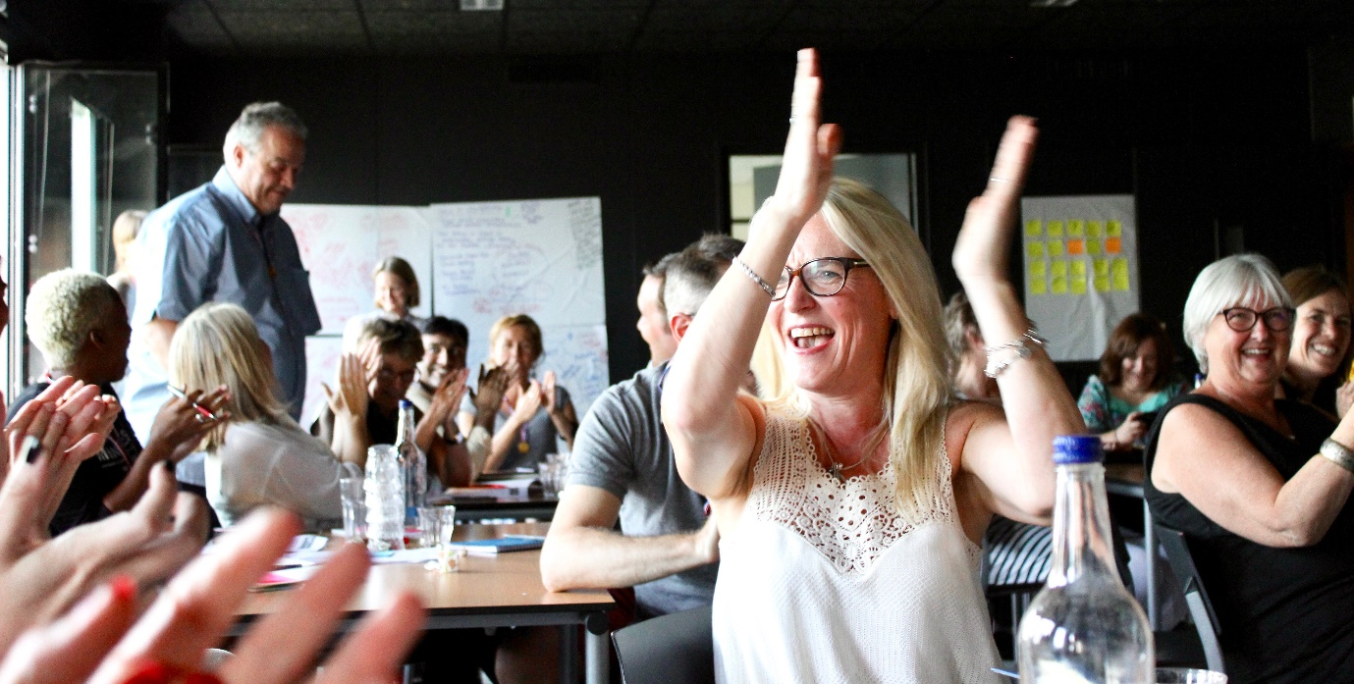

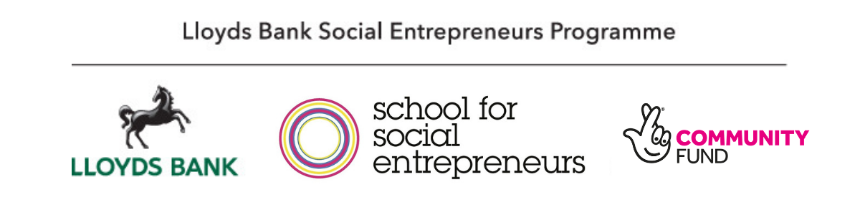

Important information for applicants
We have adapted this programme in response to the impact of the Covid-19 crisis.

Recruitment: Our recruitment process is fully online, including applications, interviews and assessment panels, while the government guidelines make this necessary.

Eligibility criteria: We will consider the impact of Covid-19 when assessing the income criteria. So, if you were expecting to have £15,000 income this year, but you are not going to because of Covid-19, please tell us about this in your application form. We will take this into account.

Learning programmes: Our learning programmes will be online until government guidance on social distancing changes. We have trialled this successfully with our existing programmes and can support you in accessing our online services. We have adapted our programmes to support social entrepreneurs through these difficult times and will work with you on recovery, resilience, and rebuilding.

Funding: We have adapted our funding model to help you get back to trading successfully. We will provide you with an upfront kick-starter grant, followed by an incentivised grant that matches an increase in trading pound-for-pound. We have called this a Trade Back grant.
.

Table of contents

Introduction 3
Eligibility 6
Can I apply? 6
About you 7
About your project 7
Please do not apply if… 8
The programme 9
What will I learn on the programme 9
What is the time commitment? 12
Where will the learning programme be held? 13
The Trade Back grant 14
What is a Trade Back grant? 14
How the Trade Back grant works for you 15
What if my income from trading does not increase? 16
What do we mean by income from trading? 16
What can I spend the grant on? 18
Can my organisation buy assets with grant? 19
How will the grant be paid to my organisation? 19
How do I apply? 21
How will by application be assessed? 23
Key contact details 24
Appendix: FAQs 24

Introduction

The Lloyds Bank and Bank of Scotland Social Entrepreneurs Programme is run in partnership with the School for Social Entrepreneurs and jointly funded by the National Lottery Community Fund.

The programme aims to give social entrepreneurs the best possible chance of success, particularly during these challenging times and changing needs of society. Social entrepreneurs are looking for ways to recover from the Covid-19 crisis, and we’re here to support them every step of the way through access to support, learning and funding.
The programme has supported over 2,000 social entrepreneurs in the UK since 2012 with over a third of the social enterprises operating in the most deprived communities in the UK.

What are these guidance notes for?
This document explains more about the programme and grant, and how to apply. Please also free to contact us if you have read the application guidance but are unsure about suitability for the programme.

Accessibility and our commitment to inclusion
If this document is formatted in a way that is not accessible to you, please email LBSEP2020@sse.org.uk or call us on 0207 089 9120 so we can share an accessible version.

We recognise that discrimination of all sorts infiltrate every part of our society, and we are working hard to counter that wherever we find it. To that end, we actively encourage applications from people of all faiths, races, gender identities, sexual orientations, economic circumstances and backgrounds, as well as those from disabled communities. No educational qualifications are needed to join our programmes.

Remember to apply in time!
The deadline for applications is 1pm, Thursday 30th April 2020.

Apply online here.

We recommend starting your application as early as possible, so we can help you with any questions you have.

The Trade Up Programme
The Lloyds Bank Social Entrepreneurs Trade Up Programme can help you if you have set up a social enterprise and need help to increase your income and impact in the year ahead. Due to the impact of Covid-19 and the current climate, this programme will be responsive to the needs of participants to support social enterprises in their journey to get back to trading through innovative learning approaches. We recognise that your focus in terms of growth and development will be how to bounce back from the crisis, accelerate recovery and build a stronger, sustainable, resilient business model.
This programme could help you:
- Learn how to strengthen your model and grow through sales, with 10-12 learning days spread over a year.
- Fund your plans with up to £4,000 Trade Back grant. Part of this will be paid up front as a kick-starter grant and part of the grant will match a growth in income from trading.
- Access to a diverse network of social entrepreneurs, who will support your plans and help you through tough times.
- Be supported by a one-to-one mentor.
- Increase your impact and reach to build a stronger future.
- Access a support network through peer learning with people in the same boat as you.
There are 60 places available at our SSE network schools in the following locations: London, Bristol, York and open to organisations from anywhere in the UK.

There are also 20 places available on Trade Up in Scotland (Edinburgh), which are available to organisations based in Scotland.

Not sure if the Trade Up programme is right for you? Consider Start Up or Scale Up on the web page here.
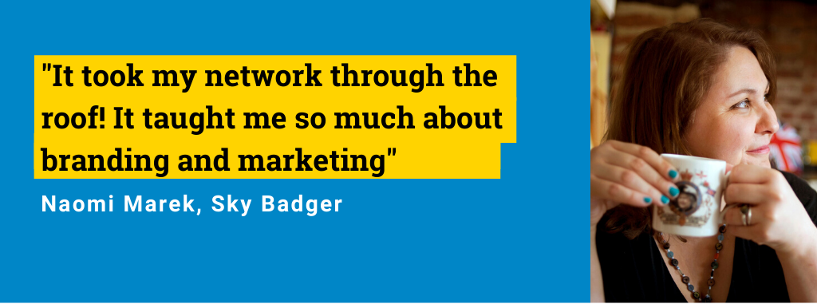

Eligibility

Can I apply?
To be eligible for this programme, your project must have been active for at least one year, have at least one paid worker, and an annual income of more than £15,000. This can be income from any source including grants, donations, trading. The majority of your beneficiaries must be in the UK.
We will consider the impact of Covid-19 when assessing the income criteria. So if you were expecting to have £15,000 income this year, but you are not going to because of Covid-19, please tell us about this in your application form. We will take this into account.
We will be looking for organisations that have realistic plans to increase their income through trading, as well as increasing their social impact. (Find out what we mean by income from trading in FAQs). You might plan to do this through:
- Developing new markets and increasing your sales.
- Developing new products and services or improving existing ones.
- Providing services in new areas.
- Developing new partnerships.
The programme works best for organisations that are experiencing change and need
support with this. It is not intended to simply replace funding for existing work or to continue the work of your organisation at a similar level.

You should be able to answer “YES” to the following questions:

About you
- Are you an individual who is leading a project that has a significant social impact?
- Are you over 16 years old?
- Do you live in the UK?
- Do you have the right to work in the UK?
- Are you committed to meeting and sharing with others who have been through and are going through the same process?
- Are you committed to learning and to attending the whole of the learning programme? (The final instalment of the grant is dependent on at least 80% attendance.)

About your project
- Is your project’s purpose to create a social or environmental impact in disadvantaged areas or with people in need?
- Do you have a realistic plan for increasing the income from trading and social impact of your project?
- Has your project been active at least one year, with income of more than £15,000 in the last or current financial year? (This means all income, e.g. grants and donations as well as income from trading. Find out more in our FAQs.) NB. We will consider the impact of Covid-19 when assessing the income criteria. So if you were expecting to have £15,000 income this year, but you are not going to because of Covid-19, please tell us about this in your application form. We will take this into account.
- Do you have at least one person working on the project who is paid regularly?
- Does your project have or will it have a formal organisation structure in place?
- Will your organisation have a clause that requires it to reinvest the majority of its profits for a social purpose?
- Will your organisation have an ‘asset lock’ clause, meaning that it must distribute any assets for social purposes, not private gain, if wound up?
- Is your project focused on benefitting communities in the UK?
- Do you have plans to increase your income from trading by at least £4,000 between October 2020 and October 2021?
If you’re not eligible for Trade Up, you can try the Start Up or Scale Up levels of this programme here.

Please do not apply if…
- You only want a grant and are not committed to attending the learning programme.
- You plan to develop a purely commercial business.
- Your project is primarily to provide business development support and advice to other organisations.
- Your project will be undertaking party political activities or will aim to induce people to convert to a religion (proselytising).
- Your project will not have a formal constitution or legal structure by the start of the programme.
- Your project’s main beneficiaries live outside the UK.

The programme

The programme at a glance:
Witness sessions
Entrepreneurs share their experiences and discuss the secrets of their success. You will be able to listen, learn and question them to help you examine and find meaning for your own project.

Expert sessions
Through questioning, observing and listening to experts, you will improve your abilities in financial management, income generation, business planning, sales and marketing, managing people, partnering and other essential skills.

Action learning sets
You will work in a small group with a trained facilitator, to help you find ways of overcoming the stumbling blocks, dilemmas and other problems that your project faces.

Mentoring
You will be matched with a mentor, who will help you build your confidence and understanding, and develop yourself and your project.

Peer support
You will bring your skills and experience to the group and learn from the skills and experience of the other members. This network of like-minded people will provide vital support to enable you to develop your enterprise.

Grant
A Trade Back grant of up to £4,000 will help you grow your project.

What will I learn on the programme?

The School for Social Entrepreneurs’ courses are different from other learning programmes. You will hear from expert practitioners and seasoned social entrepreneurs who help you develop the skills you’ll need to take your project to trade sustainably. You will also build a network of peers and get vital access to influential people within the social enterprise sector.

The course is a transformational experience that will push, challenge and support you. It will give you the confidence and skills to achieve the impact you are aiming for. In addition to the structured learning blocks, you will also join an ‘Action Learning Set’ that will provide you with a valuable forum for reflection, personal development, and developing your own solution to challenges. (Find out more about Action Learning.)

The Trade Up programme will cover relevant themes and skills areas that growing organisations need to develop through the lens of recovery, rebuilding and resilience. We will respond to the specific needs of participants and learning will be adapted to their needs. Learning sessions are likely to include these topics:
- Refine your social impact measurement
- Develop the link between your trading and your impact goals
- Develop your business plan and income streams
- Test and refine your marketing
- Grow your customer base
- Win contracts
- Improve your financial management
- Manage staff and volunteers
- Manage projects and delegate
- Improve your leadership skills
- Develop your networks

What is the time commitment?
All learning activities will take place online until government guidelines on social distancing change.
- 10-12 learning days, spread over a year
- Four meetings with your mentor, spread over a year
- At least four individual days for Actions Learning Sets. Here’s a video that explains what Action Learning is.

The learning programme is delivered in one or two-day blocks and will run for 10-12 days and at least 4 action learning sets from October 2020 to October 2021. Typically, we don’t deliver learning in the summer months or during school holidays.

A typical timeline is outlined here:
Study Days & Action Learning Set Days
2020: 1-2 days per month in October and December
2021: 1-2 days per month in January, March, April, June, July and October

Graduation Event
October 2021

The learning programme is only part of the picture though. You will need to be developing your project during the year and will need to have the time and commitment to do this.

There is also a graduation day at the end of the programme that you will be invited to attend to celebrate your achievements and completing the programme.

Where will the learning programme be held?
We will be running four Trade Up courses in England and Scotland in 2020-2021, which are open to applicants from anywhere in the UK.

These will be held in:
- South West in Bristol
- Yorkshire & North East in York
- South East in London
- Scotland in Edinburgh (Bank of Scotland Trade Up Programme)
For you are applying to the Trade Up Programme 2020-2021 in Scotland, please refer to the guidance notes for the Bank of Scotland Trade Up Programme.
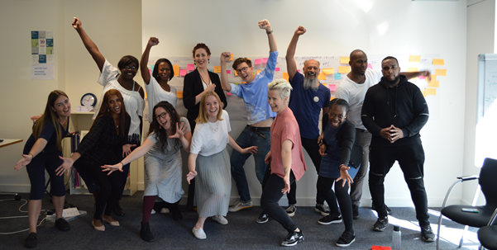

The Trade Back grant
For the Trade Up programmes in Bristol, York and London you’ll receive a Trade Back grant of up to £4,000. For Scotland, please refer to guidance notes for the Bank of Scotland Trade Up Programme.

How the Trade Back grant works
- Our new Trade Back grant will help social enterprises to get back on track following the Covid-19 crisis. We also want to support you to improve your financial sustainability by increasing your income from trading and sales.
- We will set aside £4,000 of funding for your organisation as part of this programme.
- You’ll get:
- An instant grant of £2,000 to kick-start recovery efforts and support you to put into practice new ideas and initiatives.
- Plus, up to £2,000 grant that pound-for-pound matches an increase in income from trading. This is an incentivised* grant to accelerate recovery and growth.
This element of the grant will be paid in instalments on a quarterly basis and will be matched against an increase in trading. The increase will be measured against a baseline that we will set with you. For some organisations who have struggled with trading due to the Covid-19 crisis, this baseline may be zero.

*The incentivised grant is distributed in a similar way to Match Trading grants.
- Watch our 90-second video explaining Match Trading grants here.
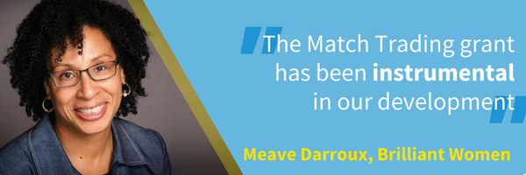
- Read stories from social entrepreneurs who’ve benefitted from Match Trading grants.

What if my income from trading does not increase?
We will work hard with you to support you to increase your trading, and we hope you will. We want to give you the money and we believe that you have the potential to achieve this growth.

If you don’t increase your income from trading at all, you will still receive the £2,000 instant grant and you will still participate and graduate from the course.

What do we mean by income from trading?
Our definition of trading is the provision of goods or services in return for a “consideration”. Consideration usually means money, but could also be in-kind or bartering, as long as this is quantified and shown in your accounts.

So income from trading includes:
- Sales of goods or services to the public, for example - selling food, tickets, training sessions, workshops
- Sales of goods or services to other organisations, for example, training courses, commissions, contracting
- Sponsorship and membership fees, where there is a significant benefit for the sponsor or member
- Rental income
It does not include:
- Donations or voluntary contributions
- Income from investments
- Bank interest
- Loans
- Equity income (e.g. through sale of shares)
- Grants, for example from trusts
- Transfers of funds from other organisations, e.g. in the case of a merger
- Sponsorship or membership fees, where there is no significant benefit to member or sponsor
We can advise you about this if you are not sure. And just to be clear, by income from trading we don’t mean surplus or profit – just income.

What can I spend the grant on?
Our intention is to be flexible as possible about how you spend the grant, but your grant must be used to support your learning and to put that learning into practice through developing trading within your organisation.

You can use your grant towards items such as:
- Your salary or staff salaries to support you to attend the programme or to support the development of trading in your organisation
- Developing new products or services
- Marketing and publicity: e.g. developing a website to support your trading
- Travel and subsistence costs, including for attending the programme
- Supplementary training for yourself or others, directly relevant to your project
- Other costs that you can show are relevant to developing your trading activity or putting your learning into practice

We cannot fund any of the following:
- Private benefit that is not “incidental” (see below)
- Assets over £1,000 in value, including refurbishment of buildings or purchase of vehicles unless agreed with us.
- Work that has taken place before the grant was awarded
- Costs associated with the application or interview
- Expenditure outside the UK, except as agreed with us
- Anything that would create religious or ethnic discord or would support illegal activities.

Costs should be value for money, meaning that you should have checked prices to ensure that you are receiving best value for money.
You must not use your grant for private benefit that is not required for the development of your project. You cannot use your grant to pay dividends and it must be used for public benefit. If in doubt, please discuss with us.

Can my organisation buy assets with grant?
You can apply for individual items of equipment or assets worth up to £1,000 per item. For example, you may need to buy specific office equipment, or intellectual property rights.

We cannot agree to pay for any individual items that are worth more than this, even if you are contributing some of the cost yourself. If you want to spend more than this on a single item, and you think the circumstances are exceptional, please contact us at LBSEP2020@sse.org.uk or call 0207 089 9120.

How will the grant be paid to my organisation?
Your organisation must have a UK bank account and this must either be solely controlled by you, or have “dual authority” – i.e. at least two people have to sign cheques or release payments.

You will need to sign terms and conditions and provide us with all necessary documents and baseline financial data before we release the first payment. In order to receive the full grant, you will need to attend at least 80% of the course and increase your income from trading as described above.
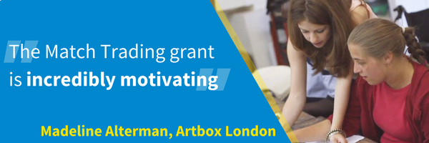

How do I apply?
Apply online by 1pm, Thursday 30th April 2020
Top tip: We recommend applying early, so we can help you if you have questions or problems. (We will be very busy in the week before the deadline.)

- Save the following documents (if they are available) in the file name format below so they are ready to upload for the application. These will likely include:
  - Your most recent annual accounts. File name format: FirstnameSurnameAccounts.doc
  - Governing document. File name format: FirstnameSurnameGoverningDocument.doc
  - Income & expenditure. File name format: FirstnameSurnameIncome&Expenditure.doc
  - Income projections. File name format: FirstnameSurnameIncomeProjections.doc
  - Documents about your impact and your work (optional). File name format: FirstnameSurnameImpactReport.doc
- Go to this page
- Click the link for Trade Up online application form.
- You can save your application and return to it at a later date. Just click “Save for later”, and you will be given a unique link to return to your application. Remember to save this link.
- When you’ve completed all the questions, click “Preview” to review your application, then click “submit”. You will be redirected to our equalities monitoring form and you will also receive a copy of your application by an email from 123 Formbuilder. Check your junk folder if you can't find the email.
If you have any problems, contact us on LBSEP2020@sse.org.uk or 0207 089 9120.

Don’t miss the deadline! Please don’t submit your application past 1pm on Thursday 30th April 2020 as it will not be considered. Under exceptional circumstances, we may grant approval to submit your application late. You need to call programme manager Helen Animashaun on 0207 089 9120 to discuss this, ahead of the deadline.
“I operate better when I’m held accountable. I knew I needed to earn the income by end of programme to access the Match Trading grant on offer.”
- Jordon Maynard-Daley, The Arts Excite

How will by application be assessed?
Our recruitment process is now fully online, and all learning activities will take place online until government guidelines on social distancing change.

May: We assess your online application
Once we have received your application, we will check that you meet the basic eligibility criteria and that your application is complete. (Please note that incomplete applications will be rejected.) Your application will then be assessed by the SSE team at your chosen location.

You will find out by early June whether your application will be taken to the next stage.

May/June: Info session & interview
If you’re accepted to the next stage, you’ll be invited to attend an information session and interview at your chosen location in May or June. We’ll make any reasonable adjustments to ensure you feel comfortable, and you can attend online if you can’t make it in person.

At this stage, we may ask you to provide your proof of identity and right to work. We’ll let you know if you’ve made it through to the next stage by June or July.

June/July: Selection panels
You will be invited to present a quick pitch of your plans to a selection panel. We’ll make any reasonable adjustments to ensure you feel comfortable, and you can attend online if you can’t make it in person.

August: Offer to join the programme
If successful, you will be offered a grant offer and learning programme package, with 30 days to sign and accept the terms and conditions.

October: The programme begins!
The learning programme starts in October 2020 and runs until October 2021.

Key contact details
If you still need advice on your application, contact us on 0207 089 9120 or by email to LBSEP2020@sse.org.uk

Complaints
If you wish to make a complaint about any aspect the programme, please see our Complaints Procedure.

Appendix: FAQs

What organisational structure will I need to have for the programme?
When you come on the programme you must have a formal organisation in place. This means your project needs to have a constitution or governing document. This should include a social purpose, a requirement that most of its profits will be returned for social purposes and an asset lock. This could be a charity, a CIC, or another form of not-for-profit or partial profit-making organisation.

If you don’t have this structure yet, then you can still apply, but you will need to have this type of formal organisation to take up a place on the programme. We can discuss this with you during the application process.

What do you mean by “active for at least a year”?
We are seeking projects with some proven track record. Your project must have been active for at least a year, either running activities or piloting programmes and ideas. It does not need to have been registered as an organisation for a year, just active.

What do we mean by “social or environmental impact in disadvantaged areas or with people in need”?
We are looking for projects that improve the lives of disadvantaged people or communities either through social or environmental benefits. You should be targeting your services to work with people in need.

We will not consider purely arts, heritage or animal projects unless they show that they are focused on improving the lives of disadvantaged people or communities.

What do you mean by “more than £15,000 income”?
We mean all income, not just income from trading – so grants and donations count.
You should have more than £15,000 income in the last financial year OR in the last 12 months, OR committed in this financial year. We would not normally consider directors loans and shares as income, but will consider this on a case by case basis.

What do you mean by “at least one person working on the project who is paid regularly”?
The project must have the resources to grow. To do this the project must have one or more people able to give time to the project and it should be at a stage where someone is paid regularly. This might be yourself, a director, staff member or regular sessional workers or administrators. It does not include paying for professional services such as an accountant or a lawyer.

What do you mean by “leading a project”?
We mean the people who come on the programme should be the ones that hold the vision for their project and are passionate about the ideas behind it. They will be the drivers of change and have the strategic ability to make the changes that are necessary. Usually this is the founder or the CEO, but it may also be the chair or a key senior manager or director.

The programme is not suitable as a training programme for people who are staff or project leaders who are simply employed to develop a project.

The course and the grant is connected to you as an individual. You cannot allocate the place to someone else in your project and if you leave the project, the grant may be withdrawn.

We recognise that, in some cases, social entrepreneurs have set up and are leading projects that are hosted within established organisations. The Trade Up Programme is open to leaders of these projects as long as they are clearly defined as a distinct part of the host organisation and have a degree of independence within it. You will need to demonstrate this. If you are unsure, please contact us via LBSEP2020@sse.org.uk

You should ensure that your organisation is willing and able to accept the grant on your behalf. If you are not the CEO, a company director, the chair or treasurer of your organisation, we will require that you provide a supporting letter from one of these people on behalf of your organisation.

What do you mean by a hosted project”?
Normally SSE supports the whole organisation, but sometimes we have applications from projects that are hosted or incubated by a wider organisation, for example, a children’s cookery club that is being hosted by a large community centre, with a view to becoming independent later. We will accept applications from hosted projects, if there is an intention that the project will become independent, and the leader of the project has a considerable level of control over the project. The expectation should be that if the leader of the project leaves the organisation, the project would go with them.”

What happens if I cease to be linked to the organisation that has the grant?
The Trade Up programme is specifically for you as a social entrepreneur and leader of the organisation you are developing. The grant is given to your organisation or to your project through a host organisation. There is a requirement that you remain a leader of that organisation during the grant and learning programme period. If you fail to do so, or you cease to be associated with the organisation that receives the grant, both the grant and the learning programme may be withdrawn.

In the case of a project that is hosted by another organisation and wants to become independent during the period of the grant, this may be possible, but we will need to make specific arrangements with you about this.

What if I have particular needs which may prevent me from fully taking part in the learning programme?
If you have any particular needs or there are any barriers that may prevent you from taking part in the programme, do talk to us about this. We are keen to enable people with disabilities and other access issues to come to our programmes.

There is a separate small fund held by the SSE to enable students who have particular needs to access the programme. This will be negotiated individually with participants. If you do have specific needs and are concerned about this, please contact us to discuss.

What happens if my project will work with children, young people or vulnerable adults?
Vulnerable adults means anyone in vulnerable situations including people who are receiving counselling, social work support, health or personal care, assistance with finances or shopping because of age, illness or disability, or transport to day centres, etc.

If your project will be undertaking unsupervised work with children under 18 years old, or working with vulnerable adults, you may need Enhanced DBS checks for staff and volunteers working with these people.

In order to receive a grant from the SSE, you will be required to show that you are following good practice on safeguarding children and vulnerable adults, including having an up to date safeguarding policy and procedure in place, which includes getting enhanced checks for people who require them.

Why are you asking about private benefit?
We know that there may be private benefits associated with your work – for example, you may pay salaries to individuals or commission private companies to do work. You may also pay dividends on shares. However, because this money is charitable, we must ensure that the grant is used for the public benefit and any private benefit is incidental – i.e. necessary to fulfil the social purpose of the project.

Sometimes, payments are necessary for the work of the project e.g. paying staff to deliver the work of the project, but if your project does provide private benefit beyond this to some individuals, we may restrict the grant to ensure that the grant is used solely for the benefit of the public.

What about other requirements?
You must ensure that health and safety standards are met to protect yourselves and others involved in your activities.

You are also responsible for ensuring that you have any insurance (e.g. contents, public liability insurance, employer’s liability insurance, professional indemnity, etc.) that is required for your activities.

You must also ensure that your project is acting within the law and that it has relevant approvals, permissions, licenses, and carries out any criminal records checks, required by law. You can apply for the cost of these as part of the grant.

If you are providing therapeutic counselling services, you must be able to demonstrate that you are properly trained and supervised, e.g. through membership of an appropriate body.

You will also be required have an equal opportunities policy in place.

If the grant is used to pay salaries, your organisation is responsible for tax and national insurance, including employer’s national insurance, which is paid over and above the salary. Please ensure you have budgeted for this. If you will be employing new staff with the grant, we will expect that jobs will be openly advertised.

Can I apply for this programme if I have criminal convictions?
Previous SSE Fellows have included people who have criminal convictions, some of whom have used their experience to make a difference to the lives of ex-offenders. You do not need to let us know about previous convictions unless they are relevant to your application.

If you have unspent convictions for fraud or convictions which may affect your ability to run your project, including working with children, young people or adults who are vulnerable, you should let us know. We may undertake checks during the course of the application assessment.

Can I apply if I have already been on a School for Social Entrepreneurs programme?
In general, you are welcome to apply if you have previously had training and support from the School for Social Entrepreneurs.

In most cases, if you are currently on an SSE programme that’s longer than six months, you won’t be able to apply for this programme. This includes any level of the Lloyds Bank and Bank of Scotland Social Entrepreneurs Programme 2019/20, the Community Business Trade Up Programme and the Fellowship Programme. Please ask your regional school if you are currently on other programmes. If you have an application pending with us for another long programme, such as Community Business Trade Up, please note that you are welcome to apply to this programme too, but you will only be able to attend one programme.

Can I apply if I was unsuccessful in the past?
If you or someone else from your organisation or project has applied before and not been successful, you are welcome to apply again. However, we would suggest that you check the feedback you received in the past. If in doubt, you can contact us.

Can I apply for Trade Up and Scale Up at the same time?
For Trade Up, you will need to show that you are an early stage and growing business, which has started and are now planning to increase your income from trading to achieve sustainability.

For Scale Up, you will need to demonstrate that you are already an established and sustainable organisation, with £75,000 annual income and 2 staff. You must be planning to significantly scale your impact over the next few years, e.g. through significantly extending your geographic reach or social franchising, develop completely new areas of work which represent a step change in increased social impact.

If you feel fulfil the criteria for both programmes, you can apply for both Scale Up and Trade Up programmes and we will review both applications. Your organisation will only be able to be placed on one programme, not both. We advise that you seek advice first if not sure.

Can more than one person from our project apply?
We will only assess applications from one person from your project or organisation. Please decide who you would like to attend the programme and they should be the one to apply. Because of the way the learning programme works and how the trust within the group is built, it is important that it is the applicant who attends all the sessions. In general, we will not allow others from your project to attend the programme.

Can I apply if I am connected to School for Social Entrepreneurs or to any of the funders of this programme?
We do not usually accept applicants whose main work is providing training or business support services primarily to other businesses, including social enterprises or charities. This would include training, fundraising or management support. However, we sometimes consider applications where the services provided are mainly back office support services, such as HR, accountancy or office space, or where training is provided for people who are unemployed in order to help them access employment. If in doubt, please contact us.

Can I apply if I am supporting other businesses including social enterprises?

We do not usually accept applicants whose main work is providing training or business support services primarily to other businesses, including social enterprises or charities. This would include training, fundraising or management support. However, we sometimes consider applications where the services provided are mainly back office support services, such as HR, accountancy or office space, or where training is provided for people who are unemployed in order to help them access employment. If in doubt, please contact us.

Will this grant fall under State Aid Regulations?
For organisations in England, the grant may fall under State Aid regulations. This refers to European legislation which, broadly speaking, makes it illegal for over Euro 200,000 of public funding to be used to subsidise a particular economic enterprise over a three year period.

However, a business may receive up to Euro 200,000 (about £180,000) of public subsidy, in any three financial years. This is called the “de minimis” level of funding.
If you have had any State Aid in the past, you should have been informed of this by the funder. Most organisations will have had no State Aid or only State Aid well below “de minimis” levels. However, because this grant comes from public funds, we are obliged to check with you before providing you with a grant. We will do this before you receive an offer of funding.

What about Data Protection?
The School for Social Entrepreneurs is committed to protecting your personal information and acting in line with your rights under data protections laws and will treat all data in accordance with our Data Protection Policy.
SSE will collect and use personal information provided by you in this form or separately, or which we otherwise lawfully obtain about you. We may use this information for;
- processing your application and managing the selection process for the programme
- conducting due diligence on you and your organisation as part of that process
This includes contacting you about the workshop or programme which you are applying for by phone or email.

If your application is successful, we may also use your information for:
- managing your participation in the Programme
- managing your grant claims and payments
- matching you with a mentor
- monitoring your progress and the impact of the programme
- sharing and promoting your story and the story of your social enterprise
- other lawful reasons
We may share your information with our funders and partners, including the National Lottery Community Fund and Lloyds Bank plc and other programme funders for monitoring and reporting purposes. They will also only use your information for the reasons outlined above.
Further details, including how we share your information and your rights relating to our use of your information, can be found under our Data Protection Notice, a copy of which is available here.

Do I need to answer the Equal Opportunities questions?
We ask you to provide your Equal Opportunities details. You are not required to give these and you can select the ‘Opt Out’ box. However, it is helpful for our future development and marketing that you provide this information. It can also help us to identify ways in which we can provide specific support to those who need it, for example applicants who may require additional support to attend interviews or participate fully in the programme.

“Brilliant social entrepreneurs, both in the room and delivering on the course. It enables you to take time out of the day-to-day and focus on the future plans - which is invaluable. And you will be challenged...”
- SSE student

