Start Up 2020-2021 Application guidance notes – large print plain text

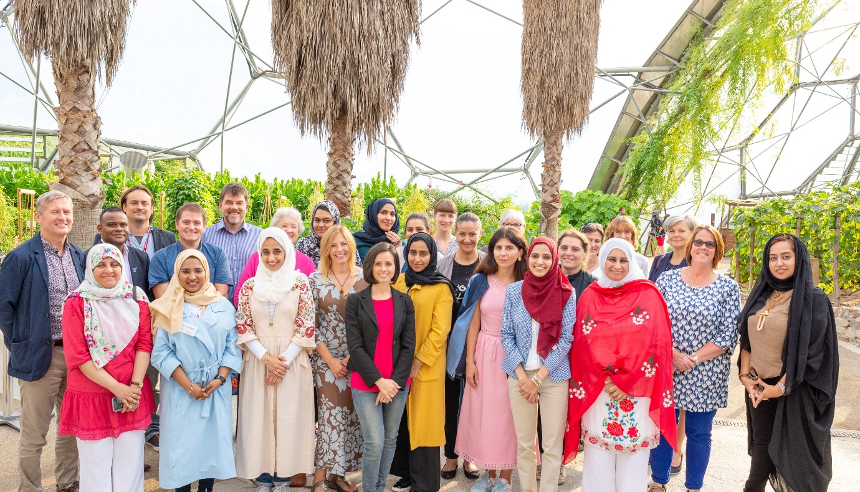
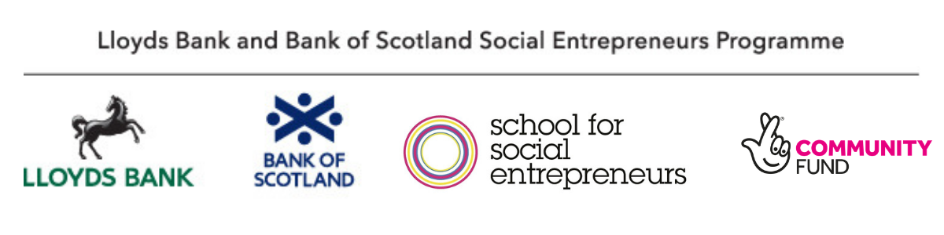

Important information for applicants
Due to Covid-19, we recognise that we may need to adapt the content of this programme. Rest assured that we will make sure the learning on this programme meets your needs.
Our recruitment process is now fully online, and all learning activities will take place online until government guidelines on social distancing change.
Please bear this in mind when reading the application guidance notes.
Table of content
s
Introduction 3
The Start Up programme 3
What are these guidance notes? 4
Accessibility and our commitment to inclusion 4
Remember to apply in time! 5
Eligibility 5
Can I apply? 5
About you 6
About your project 7
Please do not apply if… 8
The programme at a glance 9
What will I learn on the programme? 10
What is the time commitment? 11
Where will the course be held? 12
The grant 13
Can I buy assets with the grant? 15
How will my grant be paid? 15
Can I nominate an organisation to receive my grant on my behalf? 16
How do I apply? 17
How will my application be assessed? 19
Key contact details 21
Appendix: FAQs 21

Introduction
The Lloyds Bank and Bank of Scotland Social Entrepreneurs Programme is run in partnership with the School for Social Entrepreneurs and jointly funded by the National Lottery Community Fund.
The programme aims to give social entrepreneurs the best possible chance of success, through access to support, learning and funding. The programme has supported over 2,000 social entrepreneurs in the UK since 2012 with over a third of the social enterprises operating in the most deprived communities in the UK.

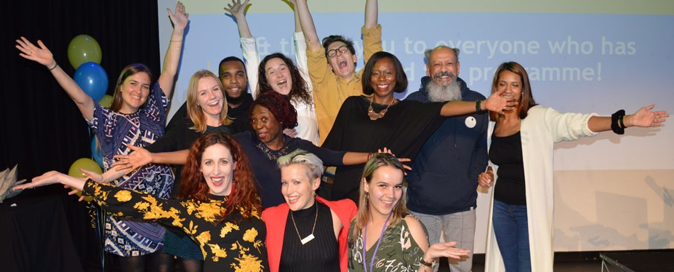

The Start Up programme
The Lloyds Bank and Bank of Scotland Social Entrepreneurs Start Up Programme will help you if you have a new project or social enterprise, or are in the early stages of setting one up. There are 160 places available across 8 Start Up locations.
This programme could help you:
- Learn how to set up and run your organisation or project: 12-15 learning days, spread over a year.
- Get financial support with a £1,000 grant.
- Get to know other social entrepreneurs, who’ll support your plans and help you through tough times.
- Be supported by a one-to-one mentor.

What are these guidance notes for?
This document explains more about the programme and grant, and how to apply. Please also free to contact us if you have read the application guidance but are unsure about suitability for the programme.

Accessibility and our commitment to inclusion
If this document is formatted in a way that is not accessible to you, please email LBSEP2020@sse.org.uk or call us on 0207 089 9120 so we can share an accessible version.
We recognise that discrimination of all sorts infiltrate every part of our society, and we are working hard to counter that wherever we find it. To that end, we actively encourage applications from people of all faiths, races, gender identities, sexual orientations, economic circumstances and backgrounds, as well as those from disabled communities. No educational qualifications are needed to join our programmes.

Remember to apply in time!
The deadline for applications is 1pm on Thursday 30th April 2020
Apply online on our website.
We recommend starting your application as early as possible, so we can help you with any questions you have.

Eligibility

Can I apply?
We want to back individuals who are committed to making a social or environmental impact, in a disadvantaged area or with people in need. You must already be leading a project, or have realistic and tested plans and be ready to start. For examples of previous entrepreneurial approaches we have supported, see the case studies on our website.
If you can answer YES to all the following questions, then you can apply for the Start Up programme.

About you
- Are you an individual who is leading or setting up a project, which will create social or environmental impact, working in disadvantaged areas or with people in need? (See the FAQs if you need more info on this.)
- Are you over 16 years old?
- Do you live in the UK?
- Do you have the right to work in the UK?
- Are you committed to meeting and sharing with others who have been through and are going through the same process?
- Are you committed to attending the learning programme on at least 12-15 days between October 2020 and October 2021 at one of our locations?

About your project
- Is your project or organisation less than two years old, with income of less than £15,000 per year? OR Is it in the planning stages, but ready to start? (See the FAQs if you need more info on this.)
- Is your project’s purpose to create a social or environmental impact, in disadvantaged areas or with people in need?
- Have you already taken some steps to put your ideas into action and have you tested your ideas?
- Is your project focused on benefitting communities in the UK? (We are unable to support international projects within this programme.)
- Will your project reinvest the majority of its profits for a social purpose? The majority of the profits (after you have paid reasonable salaries) must be reinvested in the project or organisation or be put towards furthering a social or environmental purpose.
- If your organisation or project stopped running, would any assets left go to good causes or be distributed for a social purpose, not to individuals or for private gain?
- Will you be able to use a £1,000 grant to support your learning and the development of your project between October 2020 and October 2021?

If your project’s annual income is more than £15,000, try Trade Up or Scale Up.

Please do not apply if…
- You only want a grant and do not intend to attend the learning programme.
- You plan to develop a purely commercial business.
- Your project is primarily to provide business development support and advice to other organisations.
- Your project will be undertaking party political activities or will aim to induce people to convert to a religion (proselytising).
- You want to develop projects whose main beneficiaries live outside the UK.
- You only plan to run a one-off event or activity.
- The organisation you are leading has been active for more than two years at the time of the application. (If this applies to you, try Trade Up or Scale Up.)
- You plan to use your grant fund your salary or living costs.
- You are barred from running a company or charity.
- You have an unspent conviction for fraud.
- You are currently declared bankrupt or have a Debt Relief Order.
- Other people from your project are also applying or you think you may send someone else in your place during the programme. Only one applicant from each project or organisation can attend the learning programme.

The programme
Witness sessions
Entrepreneurs share their experiences and discuss the secrets of their success. You will be able to listen, learn and question them to help you examine and find meaning for your own project.
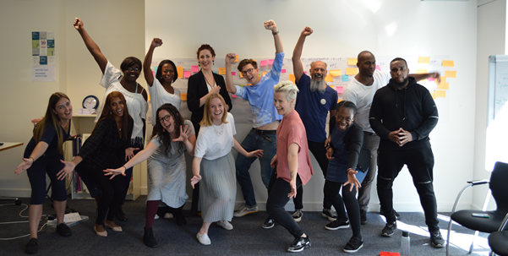
Expert sessions
Through questioning, observing and listening to experts, you will improve your abilities in financial management, income generation, business planning, sales and marketing, managing people, partnering and other essential skills.
Action learning sets
You will work in a small group with a trained facilitator, to help you find ways of overcoming the stumbling blocks, dilemmas and other problems that your project faces.
Mentoring
You will be matched with a mentor, who will help you build your confidence and understanding, and develop yourself and your project.
Peer support
You will bring your skills and experience to the group and learn from the skills and experience of the other members. This network of like-minded people will provide vital support to enable you to develop your enterprise.
Grant
A £1,000 grant will help you get your project off the ground.

What will I learn on the programme?
The Start Up programme helps you to get a new social enterprise up and running. Our learning programmes are very different to traditional teaching. We’re not about essays and academia. We believe in learning from other people’s experiences. You’ll hear from inspiring social entrepreneurs who speak frankly about the good, the bad and the ugly of running an organisation.
This playlist of videos shows the type of story you might hear.
You’ll learn about how to:
- Set up your organisation, using a suitable legal structure.
- Make money and develop your business model.
- Manage finances.
- Develop your impact and purpose.
- Keep a work/life balance.
- Build networks.
- Do marketing and social media.
- Build confidence in your leadership skills.
Due to Covid-19, we recognise that we may need to adapt the content of this programme. Rest assured that we will make sure the learning on this programme meets your needs.
You’ll be in a group of around 20 people who are at a similar stage to you, starting up a social or environmental project. (More info below.)
The course is a transformational experience that will push, challenge and support you. It will give you the confidence and skills to achieve the impact you are aiming for. In addition to the structured learning blocks, you will also join an ‘Action Learning Set’ that will provide you with a valuable forum for reflection, personal development, and developing your own solution to challenges.

What is the time commitment?
All learning activities will take place online until government guidelines on social distancing change. Therefore, the following information is subject to change.
In total:
- 12-15 learning days, spread over a year.
- Four meetings with your mentor spread over a year.
A typical timeline is outlined here, but this may vary slightly from school to school:
- Study days (8 full days): 2 days in October 2020; 2 days in November or December 2020; 2 days in February 2021; 1 day in April 2021; 1 day in September or October 2021.
- Action learning sets (4 full days): 1 day each in January 2021, April 2021, June 2021 and September or October 2021.
We don’t normally deliver learning in the summer months or during school holidays.
In addition to the above you will need to set aside time to meet with your mentor. You and your mentor will schedule your meetings at times to suit you both: generally four sessions, each lasting around 1.5 hours through the year.
There is also a graduation event at the end of the programme which you will be invited to attend, to celebrate your achievements and your completion of the programme.
The learning programme is only part of the picture though. You will need to be developing your project during the year and will need to have the time and commitment to do this.

Where will the course be held?
All learning activities will take place online until government guidelines on social distancing change. Therefore, the following information is subject to change.
The programme will run in eight locations in England. When you apply online, you must be able to travel to attend training at your selected school location. You can include reasonable travel costs to attend the training as part of your grant budget.
Please note that it is likely that London will be oversubscribed, so applying to a different location may increase your chances of getting a place on the programme.

SSE School and its corresponding programme location
SSE East – Ipswich
SSE London – London
SSE Hampshire – Winchester
SSE Midlands – Birmingham
SSE North West – Liverpool
SSE Cornwall – Truro
SSE Dartington – Dartington
SSE Yorkshire & North East - York

The grant
You receive a grant of £1,000, paid in two instalments. You can use the grant to attend the programme and to help with the costs of developing your project. The grant can be spent on travel costs, running costs, marketing and other things to support the development of your project and implement your learning.
You will be required to attend the learning programme to receive the grant. You will need to be able to spend your grant between October 2020 and October 2021.
It is helpful if you can tell us how you might spend your grant, but you can change this later in agreement with us. If you don’t know yet, just say you don’t know. It won’t affect your application.
You will be matched with a grant manager throughout the year, who will support you with questions about your grant and how you can spend it.

What you can use the grant for
- The costs of attending the learning programme, including travel and subsistence
- Project running costs - e.g. office rent, telephone calls, stationery for use directly on your project
- Events and activities
- Marketing and publicity - e.g. developing a website
- Salaries for sessional staff
- Other travel expenses
- Volunteer expenses
- Criminal records checks
- Supplementary training for yourself or others directly relevant to the development of your project
- Other items that you can show are relevant to developing your project
- Other items that you can show are relevant to developing your project
- Insurance

What we cannot fund
- Your salary (including payment to yourself as a sessional worker), living costs or childcare
- Renting office space in your own house
- Academic studies, or those that are not relevant to the development of your project
- Costs incurred before the grant is awarded
- Refurbishment of buildings
- Any illegal activities
- Expenditure outside of the UK without prior agreement.

Can I buy assets with the grant?
If you want to use the grant to contribute to a piece of equipment or an asset that is worth more than £1,000, such as purchasing a vehicle or building, you will need to talk to your grant manager first.

How will my grant be paid?
You must have a UK bank account in your name only when you receive your grant. We cannot pay into joint accounts; though we may be able to pay to an organisation on your behalf (see below).
- Your grant will usually be paid in two instalments at the start and end of the programme year. We will pay £750 at the start of the programme and £250 at the end of the programme, once you have completed all the grant requirements.
- You will need to agree and sign terms and conditions and provide us with all the necessary documents before we release the first payment. You will also need to provide us with some monitoring and financial information so we can release the remaining payments.
- In order to receive the full grant, you will need to attend at least 80% of the learning programme.

We will work with you if you face genuine difficulties in claiming or spending your grant.

Can I nominate an organisation to receive my grant on my behalf?
For various reasons, some people want the grant paid directly to their organisation, or to a host organisation on their behalf.
If you are accepted on the programme, we will ask you if you want to make this arrangement. We will need to do some checks to make sure that the organisation is willing and able to accept the grant on your behalf and agree terms and conditions with that organisation.

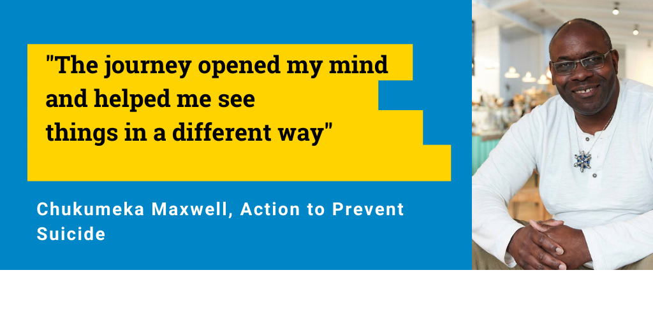

How do I apply?
Apply online by 1pm, Thursday 30th April 2020
Top tip: We recommend applying early, so we can help you if you have questions or problems. (We will be very busy in the week before the deadline.)
- Go to this webpage
- Click the link for Start Up which will take you to our online application form.
- Complete your online application.
- You can save your application and return to it at a later date. Just click “Save for later”, and you will be given a unique link to return to your application. Remember to save this link.
- When you’ve completed all the questions, click “Preview” to review your application, then click “submit”. You will be redirected to our equalities monitoring form and you will also receive a copy of your application by email from us (via 123 Formbuilder). Check your junk folder if you can't find the email.
If you have any problems, contact us on LBSEP2020@sse.org.uk or 0207 089 9120.

Top tip: If you want to include a governing document, your accounts or any additional documents in your application (these are all optional), save them in the format “FirstnameSurnameAccounts.doc”, “FirstnameSurnamegoverning.doc” etc. so they are ready to attach.
Don’t miss the deadline! Please don’t submit your application after 1pm, Thursday 30th April 2020 as it will not be considered. Under exceptional circumstances, we may grant approval to submit your application late. You need to call programme manager Helen Animashaun on 0207 089 9120 to discuss this, ahead of the deadline.

How will my application be assessed?
Our recruitment process is now fully online, and all activities will take place online until government guidelines on social distancing change. Therefore, the following information is subject to change.
- May: We assess your online application
Once we have received your application, we will check that you meet the basic eligibility criteria and that your application is complete. (Please note that incomplete applications will be rejected.) Your application will then be assessed by the SSE team at your chosen location.
You will find out by end of the May whether your application will be taken to the next stage.

May/June: Info session & interview
If you’re accepted to the next stage, you’ll be invited to attend an information session and interview at your chosen location in May or June. We’ll make any reasonable adjustments to ensure you feel comfortable, and you can attend online if you can’t make it in person.
At this stage, we may ask you to provide your proof of identity and right to work. We’ll let you know if you’ve made it through to the next stage by June or July.

June/July: Selection panels
You will be invited to present a quick pitch of your plans to a selection panel. We’ll make any reasonable adjustments to ensure you feel comfortable, and you can attend online if you can’t make it in person.

August: Offer to join the programme
If successful, you will be offered a grant offer and learning programme package, with 30 days to sign and accept the terms and conditions.

October: The programme begins!
The learning programme starts in October 2020 and runs until October 2021.

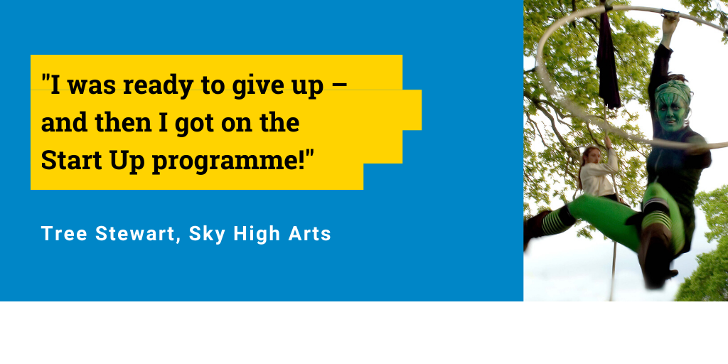

Key contact details
If you need any advice on your application, please contact us on 0207 089 9120 or by email at LBSEP2020@sse.org.uk
For more information please go to:
- the main programme page
- the Start Up programme page

Complaints
If you wish to make a complaint about any aspect of the programme, please see our Complaints Procedure.

Appendix: FAQs

What do we mean by “social or environmental impact in disadvantaged areas or with people in need”?
We are looking for projects that improve the lives of disadvantaged people or communities either through social or environmental benefits. You should be targeting your services to work with people in need.
We will not consider arts, heritage or animal projects unless they show that they are focused on improving the lives of disadvantaged people or communities.

What do you mean by “in planning stages, but ready to start”?
You may not have started your project yet, but we want to know that you have been working on the planning and that the project is ready to start. We want to know why you think your project will work and how you know you can deliver it. We don’t expect all projects to be successful and we are happy to take a risk with you, but we want to know that there is a good chance of your project succeeding. You need to show us how you have tested your ideas and know your plans have a realistic chance of success.
We would expect that you can respond to some or all of the questions below:
- Have you had direct experience of the issues or of similar projects?
- Have you found out who else is running the kind of project you are proposing? Why will your project be different or additional to theirs?
- Have you talked to people about whether your project is seeking to help their needs, and about your ideas?
- Have you talked to experts in the field or people who have run similar projects?
- Have you started running activities or run a pilot project?

What do you mean by “an annual income of less than £15,000”?
If you had income of less than £15,000 in the last 12 months, from grants, sales or contracts that is fine.
If you have recently received a larger grant or contract, which has come in already but is for work to be completed over the coming year, then you may still be eligible. Contact us for advice.

What if I have particular needs which may prevent me from fully taking part in the learning programme?
If you have any particular needs or there are any barriers that may prevent you from taking part in the programme, do talk to us about this. We are keen to enable people with disabilities and other access issues to come to our programmes.

There is a separate small fund held by the SSE to enable students who have particular needs to access the programme. This will be negotiated individually with participants. If you do have specific needs and are concerned about this, please contact us to discuss.

What happens if my project will work with children, young people or vulnerable adults?
Vulnerable adults means anyone in vulnerable situations including people who are receiving counselling, social work support, health or personal care, assistance with finances or shopping because of age, illness or disability, or transport to day centres, etc.

If your project will be undertaking unsupervised work with children under 18 years old, or working with vulnerable adults, you may need Enhanced DBS checks for staff and volunteers working with these people.

The SSE can provide you with advice on this when you are setting up your project. You will be required to show that;
- You have an up-to-date criminal records disclosure. We can advise you on how to get this.
- Once you start providing services, you are following good practice on safeguarding, including getting enhanced checks for people who require them.

What about other requirements?
- You must ensure that health and safety standards are met to protect yourselves and others involved in your activities.
- You must have any insurance (e.g. public liability Insurance, employer’s liability insurance, equipment insurance etc.) that is required for your activities.
- You must also ensure that you have any approvals, permissions, licenses or carry out any criminal record checks required by law.
- If you are providing therapeutic counselling services, you must be able to demonstrate that you are properly trained and supervised, e.g. through membership of an appropriate body. If you haven’t got this already, we may make it a condition of your grant.
- You will also be required to put Equal Opportunities procedures in place once your project has started. We can advise you about this.
- You will be able to put your grant towards these costs.

Can I apply if my project is hosted by a larger organisation?
You don’t need to have established a formal organisation, but if you have, it must have been set up for less than two years at the time of application. Your project may be hosted by a larger and older organisation. If so, it will have to have a degree of independence within that organisation. However, we do not normally accept franchises or organisations that are controlled by a local authority.

Can I apply if I have a full-time job?
You can apply to the programme if you are in full-time employment as long as you are able to manage your project and attend the learning programme in a way that fits in with your employment commitments. We would also expect you to have time to develop your project during the year, outside of the learning programme.

Can I apply for this programme if I have criminal convictions?
Previous SSE fellows have included people who have criminal convictions, some of whom have used their experience to make a difference to the lives of ex-offenders. You do not need to let us know about previous convictions unless they are relevant to your application.
If you have unspent convictions for fraud or any convictions which may affect your ability to run your project, including working with children, young people or adults who are vulnerable, you should let us know, as we may undertake checks during the course of the application assessment.

Can I apply if I already have been on an SSE programme?
If you have only been on short courses or workshops with SSE, then yes.
If you have been on an SSE Fellowship or other Start Up Programme before, we would expect you to have already started your project, so the Start Up Programme will not be relevant. The Trade Up or Scale Up programme, for more established projects, might be of more interest to you.
If there were exceptional circumstances as to why you did not complete the previous SSE programme, we may consider your application - please discuss this with us first.
If you are currently on any SSE programme that’s longer than six months, you cannot apply for this programme. This includes any level of the Lloyds Bank and Bank of Scotland Social Entrepreneurs Programme 2019-2020, Community Business Trade Up 2019-20, the Fellowship Programme, and other long programmes run across the country.

Can I apply if unsuccessful in the past?
If you or someone else from your organisation or project has applied before and not been successful, you are welcome to apply again. We often have people on our programme who are applying for the second or third time, and whose ideas or plans have developed since they first applied. However, we would suggest that you check the feedback you received in the past. If in doubt, you can contact us.

Can more than one person from our project apply?
We will only assess applications from one person from your project or organisation. Please decide who you would like to attend the programme and they should be the one to apply. Because of the way the learning programme works and how the trust within the group attending the learning programme is built, it is important that it is the applicant who attends all the sessions. In general, we will not allow others from your project to attend the programme.

Can I apply if I am connected to the School for Social Entrepreneurs, or to any of the funders of this programme?
We cannot accept applications from people who are staff or trustees of SSE. If you have a close connection with SSE, its host organisations, staff, trustees or the funders of this programme, please contact us before making an application.

Can I apply if I am supporting other businesses including social enterprises?
We do not usually accept applicants whose main work is providing training or business support services primarily to other businesses, including social enterprises or charities. This would include training, fundraising or management support. However, we sometimes consider applications where the services provided are mainly back-office support services, such as HR, accountancy or office space, or where training is provided for people who are unemployed in order to help them access employment. If in doubt, please contact us.

Can I apply if my project is a franchise?
We do not usually accept applications from projects that are franchises of another project. We expect that you would receive the support you need to set up from the parent organisation.

Can I apply if my project is controlled by a public sector organisation?
We accept applications from projects which are public sector roll-outs, or set up with the support of local authorities, as long as they are now fully independent. However, we do not usually accept applications from projects or organisations that are controlled by a public-sector organisation. If in doubt, please contact us.

What about Data Protection?
The School for Social Entrepreneurs is committed to protecting your personal information and acting in line with your rights under data protections laws and will treat all data in accordance with our Data Protection Policy.
SSE will collect and use personal information provided by you in your online application or separately, or which we otherwise lawfully obtain about you. We may use this information for:
- processing your application and managing the selection process for the programme
- conducting due diligence on you and your organisation as part of that process
This includes contacting you about the workshop or programme which you are applying for by phone or email.
If your application is successful, we may also use your information for:
- managing your participation in the programme
- managing your grant claims and payments
- matching you with a mentor
- monitoring your progress and the impact of the programme
- sharing and promoting your story and the story of your social enterprise online or externally
- other lawful reasons
We may share your information with our funders and partners, including the National Lottery Community Fund and Lloyds Bank plc and other programme funders for monitoring and reporting purposes. They will also only use your information for the reasons outlined above
Further details, including how we share your information and your rights relating to our use of your information, can be found under our Data Protection Notice, a copy of which is available here.
We ask you to provide information for Equal Opportunities monitoring purposes. You are not required to give these and you can select the ‘Opt Out’ box. It can help us to identify ways in which we can provide specific support to those who need it, for example applicants who may require additional support to attend interviews or participate fully in the programme. It is also helpful for our future development and marketing that you provide this information.
