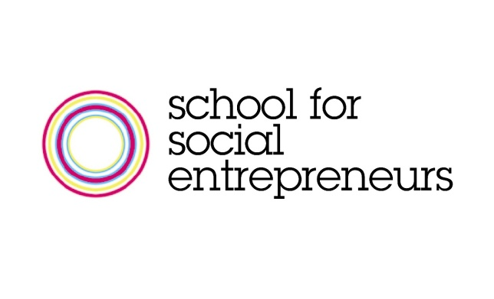

National Programme Manager, School for Social Entrepreneurs
London
Starting £35,471 to £36,254 + 5% pension

Are you an experienced programme manager looking to take on a new challenge and create a real impact?

We are looking for a National Programme Manager to lead on the delivery of a new programme for SSE. The Community Business Trade Up programme is currently being piloted in two locations. This role will be responsible for rolling it out to 10 locations across England. You will lead on planning and establishing programme management and reporting systems, on ensuring high quality delivery in partnership with our 8 schools across England and will work closely with the Development Manager to ensure excellent relationships with the programme funder.

The School for Social Entrepreneurs (SSE) is the leading provider of learning programmes that support and develop social entrepreneurs: individuals working entrepreneurially to create social benefit. The SSE runs practical learning programmes aimed at helping develop both the individual social entrepreneur and their organisation. Our approach, and belief, is that social change is people-powered, and that the most valuable assets and resources we have are human ones.

This role will suit you if you are highly organised, with excellent communications and influencing skills and an ability to balance the big picture with a keen attention to detail.

Please see the attached application pack for further details on the role and how to apply.

