Directions to the School for Social Entrepreneurs (SSE) London

2nd Floor, The Fire Station, 139 Tooley Street, London, SE1 2HZ
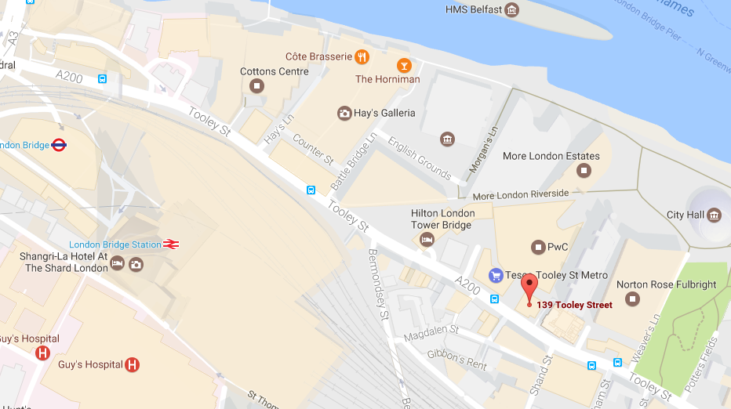
Nearest Main Line Station:
London Bridge
Getting in to the office:
We are based in the old red brick Fire Station. The ground floor is occupied by the Brigade Bistro, so you’ll need to use the side entrance located on Abbotts Lane. Ring the bell for the 2nd floor marked ‘SSE’ and we’ll buzz you in – just wait for the light next to the door to go green then pull the handle firmly down and towards you. There are stairs on the right or a lift through the door on the left which you can take to the 2nd floor.
Reaching us by London Underground:
Jubilee or Northern Line (Bank Branch) to London Bridge. Take Exit 3 on to Tooley Street and turn right. You will pass the Hilton Hotel on your left followed by Tesco and Costa Coffee. Immediately after this is Abbotts Lane.
By bus:
Routes 47, 343, 381 and RV1 all stop at Tooley Street/City Hall bus stop very close to our office (approximately a 1 minute walk). Alternatively, any bus to London Bridge station will drop you off approximately a 5 to 7 minute walk away.
By bike or car:
Cycle racks are available on Abbots Lane, next to the entrance to the office. Unfortunately, there is no onsite parking. The nearest car parks is the NCP at the junction of Snowsfields and Kipling Street (approximately 600 metres).

